Chennai

Date | Publication | Edition | Reporter | Headlines
Aug 9 2008 | The Hindu | Chennai | Bureau | Are you an IT wiz?
Aug 10 2008 | The Hindu | Chennai | Bureau | QUIZZING KIDS
Aug 13 2008 | The New Indian Express | Chennai | Bureau | QUIZ CONTEST BY TCS
Aug 14 2008 | The Hindu | Chennai | Bureau | TCS Quiz
Aug 15 2008 | The Times of India | Chennai | Bureau | TCS IT Wiz, Music Academy, TTK Road, 10.30 am
Aug 15 2008 | The New Indian Express | Chennai | Bureau | Quizzing away
Aug 21 2008 | The Hindu | Chennai | Bureau | Inter-school IT Quiz
Aug 21 2008 | Daily Thanthi | Chennai | Bureau | Inter-school IT Quiz
Aug 21 2008 | Tamil Oosai | Chennai | Bureau | TCS quiz competition
Aug 22 2008 | The Hindu | Chennai | Bureau | Magic formula opens golden gate to success
Aug 22 2008 | Dina Bhoomi | Chennai | Bureau | TCS IT Wiz 2008
Aug 23 2008 | News Today | Chennai | Bureau | PSBB students take the cake in IT quiz
Aug 26 2008 | Tamil Chudar | Chennai | Bureau | TCS IT Wiz
Aug 30 2008 | Dinamani | Chennai | Bureau | TCS - QUIZ
Sep 1 2008 | The New Indian Express | Chennai | Bureau | IT Wiz, a quiz on IT

Publication: | The Hindu |  | Page 1 of 1
Edition: | Chennai
Date: | Aug 9 2008
Page: | 7

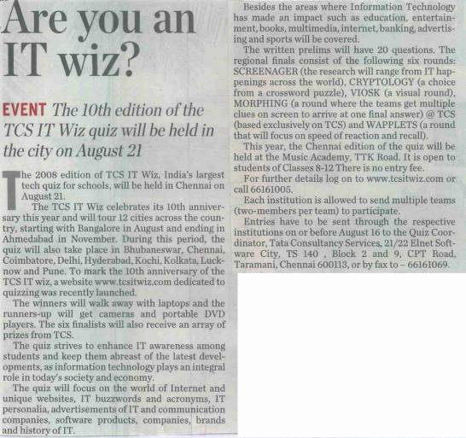

Back to grid

Publication: | The Hindu |  | Page 1 of 1
Edition: | Chennai
Date: | Aug 10 2008
Page: | 2

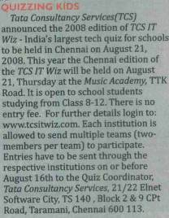

Back to grid

Publication: | The New Indian Express |  | Page 1 of 1
Edition: | Chennai
Date: | Aug 13 2008
Page: | 2

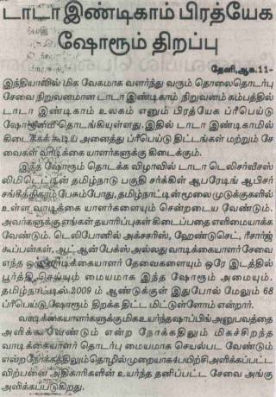

Back to grid

Publication: | The Hindu |  | Page 1 of 1
Edition: | Chennai
Date: | Aug 14 2008
Page: | 3

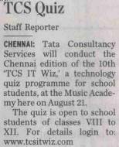

Back to grid

Publication: | The Times of India |  | Page 1 of 1
Edition: | Chennai
Date: | Aug 15 2008
Page: | 20

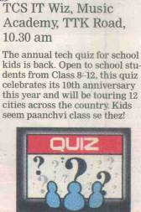

Back to grid

Publication: | The New Indian Express |  | Page 1 of 1
Edition: | Chennai
Date: | Aug 15 2008
Page: | 13

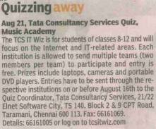

Back to grid

Publication: | The Hindu |  | Page 1 of 1
Edition: | Chennai
Date: | Aug 21 2008
Page: | 2



Back to grid

Publication: | Daily Thanthi |  | Page 1 of 1
Edition: | Chennai
Date: | Aug 21 2008
Page: | 10

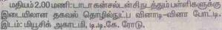

Back to grid

Publication: | Tamil Oosai |  | Page 1 of 1
Edition: | Chennai
Date: | Aug 21 2008
Page: | 3

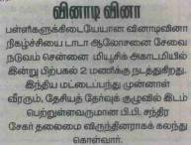

Back to grid

Publication: | The Hindu |  | Page 1 of 1
Edition: | Chennai
Date: | Aug 22 2008
Page: | 2

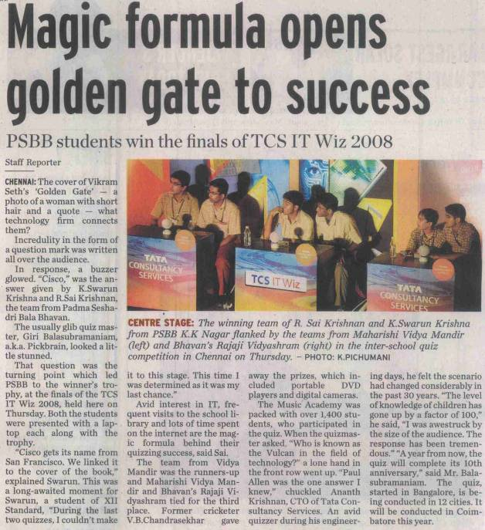

Back to grid

Publication: | Dina Bhoomi |  | Page 1 of 1
Edition: | Chennai
Date: | Aug 22 2008
Page: | 2

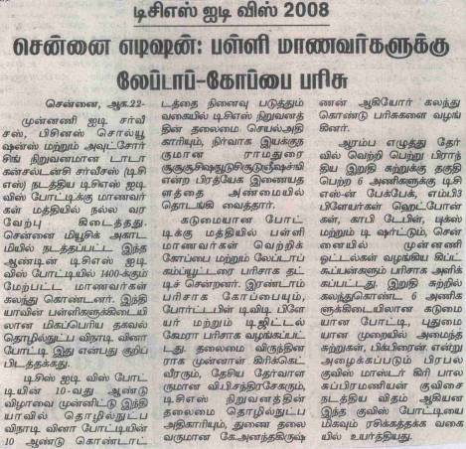

Back to grid

Publication | News Today |  | Page 1 of 2
Edition | Chennai
Date | Aug 23 2008
Page | 1,3

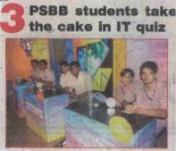

Publication | News Today |  | Page 2 of 2
Edition | Chennai
Date | Aug 23 2008
Page | 1,3

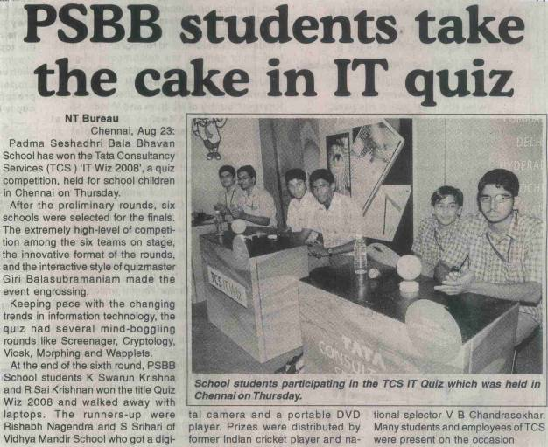

Back to grid

Publication: | Tamil Chudar |  | Page 1 of 1
Edition: | Chennai
Date: | Aug 26 2008
Page: | 9

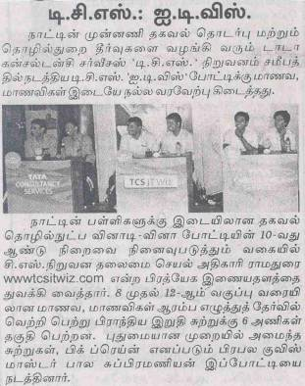

Back to grid

Publication: | Dinamani |  | Page 1 of 1
Edition: | Chennai
Date: | Aug 30 2008
Page: | 1

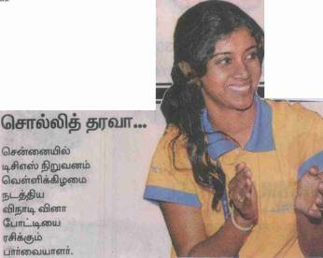

Back to grid

Publication: | The New Indian Express |  | Page 1 of 1
Edition: | Chennai
Date: | Sep 1 2008
Page: | 2

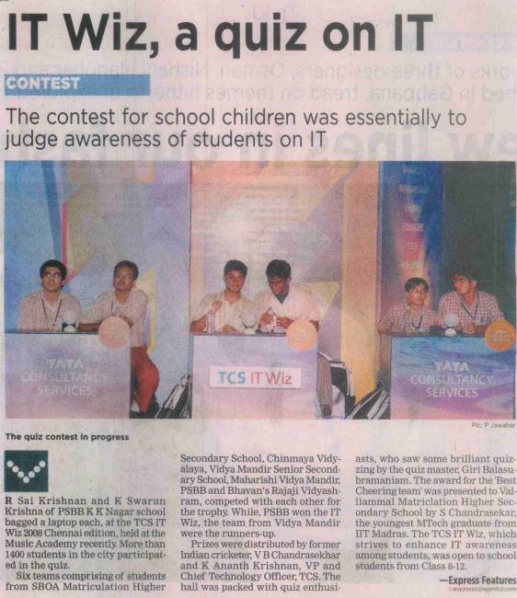

Back to grid

