Hyderabad

Date | Publication | Edition | Reporter | Headlines
Aug 12 2008 | Eenadu | Hyderabad | Bureau | TCS quiz competition
Aug 13, 16, 21, 22, 23 2008 | The Times of India | Hyderabad | Bureau | Quiz
Aug 12, 13, 15, 16, 23 2008 | Deccan Chronicle | Hyderabad | Bureau | Quiz
Aug 23 2008 | Andhra Prabha | Hyderabad | Bureau | TCS quiz
Aug 23 2008 | The Hindu | Hyderabad | Bureau | TCS IT Wiz - Tech Quiz for school students today
Aug 23 2008 | The New Indian Express | Hyderabad | Bureau | Rejuvinate
Aug 24 2008 | Andhra Jyoti | Hyderabad | Bureau | Chirac Public School wins TCS quiz
Aug 24 2008 | Eenadu | Hyderabad | Bureau | TCS quiz
Aug 28 2008 | You And I | Hyderabad | Bureau | IT Wiz Quiz
Sep 2 2008 | The Hindu | Hyderabad | Preeti Raghunath | Wizards at quiz

Publication: | Eenadu |  | Page 1 of 1
Edition: | Hyderabad
Date: | Aug 12 2008
Page: | 14

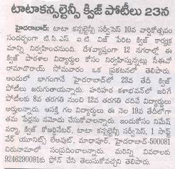

Back to grid

Publication: | The Times of India |  | Page 1 of 1
Edition: | Hyderabad
Date: | Aug 13 2008
Page: | 2

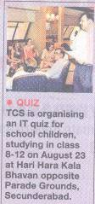

Back to grid

Publication: | Deccan Chronicle |  | Page 1 of 1
Edition: | Hyderabad
Date: | Aug 12 2008
Page: | 26

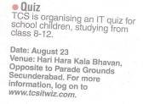

Back to grid

Publication: | Andhra Prabha |  | Page 1 of 1
Edition: | Hyderabad
Date: | Aug 23 2008
Page: | 13

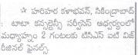

Back to grid

Publication: | The Hindu |  | Page 1 of 1
Edition: | Hyderabad
Date: | Aug 23 2008
Page: | 2

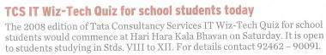

Back to grid

Publication: | The New Indian Express |  | Page 1 of 1
Edition: | Hyderabad
Date: | Aug 23 2008
Page: | 1



Back to grid

Publication: | Andhra Jyoti |  | Page 1 of 1
Edition: | Hyderabad
Date: | Aug 24 2008
Page: | 16

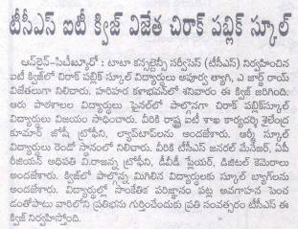

Back to grid

Publication: | Eenadu |  | Page 1 of 1
Edition: | Hyderabad
Date: | Aug 24 2008
Page: | 31

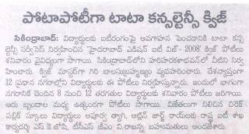

Back to grid

Publication: | You And I |  | Page 1 of 1
Edition: | Hyderabad
Date: | Aug 28 2008
Page: | 76

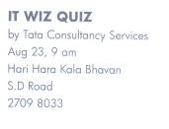

Back to grid

Publication: | The Hindu |  | Page 1 of 1
Edition: | Hyderabad
Date: | Sep 2 2008
Page: | 6

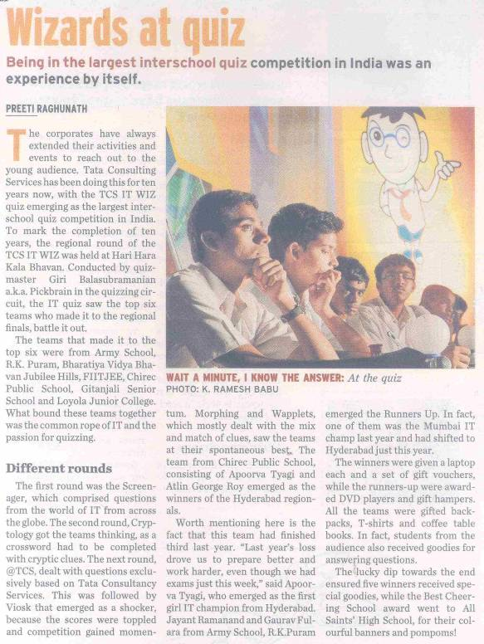

Back to grid

