Pune

Date | Publication | Edition | Reporter | Headlines
Aug 13 2008 | The Indian Express | Pune | Bureau | 'TCS IT Wiz' school quiz on August 26
Aug 14 2008 | DNA | Pune | Bureau | TCS quiz on Aug 26
Aug 17 2008 | Sakal | Pune | Bureau | Quiz contest from TCS
Aug 17 2008 | Sakal Times | Pune | Bureau | Quiz contest
Aug 26 2008 | Hindu Business Line | Mumbai, New Delhi, Hyderabad, Chennai, Kolkata, Bangalore | Bureau | TCS quiz for schools
Aug 27 2008 | Sakal | Pune | Bureau | Dr. Shyamrao Kalmadi College winner of IT Quiz
Aug 27 2008 | Lokmat | Pune | Bureau | Kalmadi High School came first in 'TCS IT Quiz'
Aug 27 2008 | The Indian Express | Pune | Bureau | Wiz kids
Aug 30 2008 | The Times of India | Pune | Bureau | TCS IT Quiz results
Aug 31 2008 | Sakal Times | Pune | Bureau | TCS IT Wiz conducted

Publication: | The Indian Express |  | Page 1 of 1
Edition: | Pune
Date: | Aug 13 2008
Page: | 2

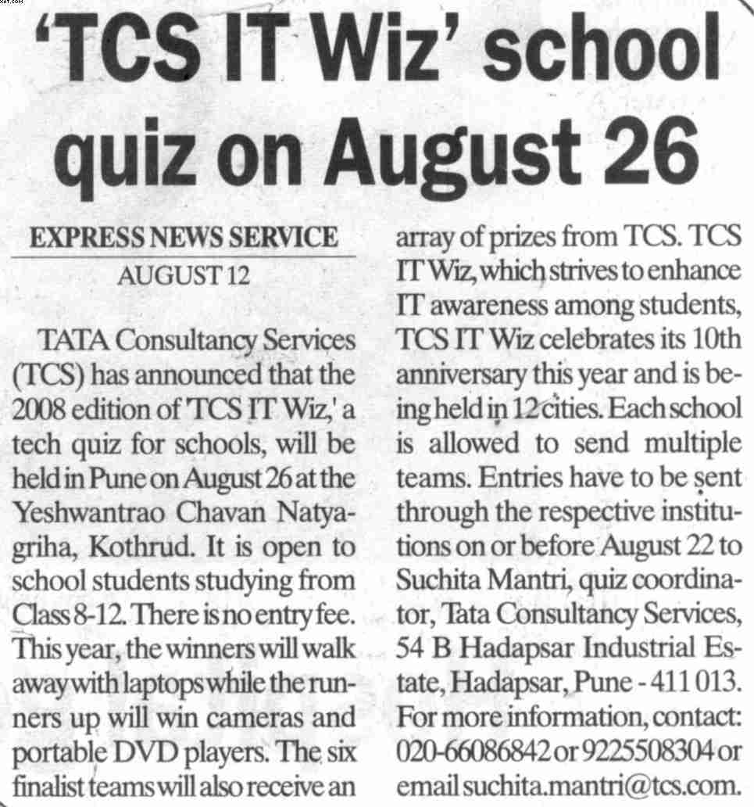

Back to grid

Publication: | DNA |  | Page 1 of 1
Edition: | Pune
Date: | Aug 14 2008
Page: | 4

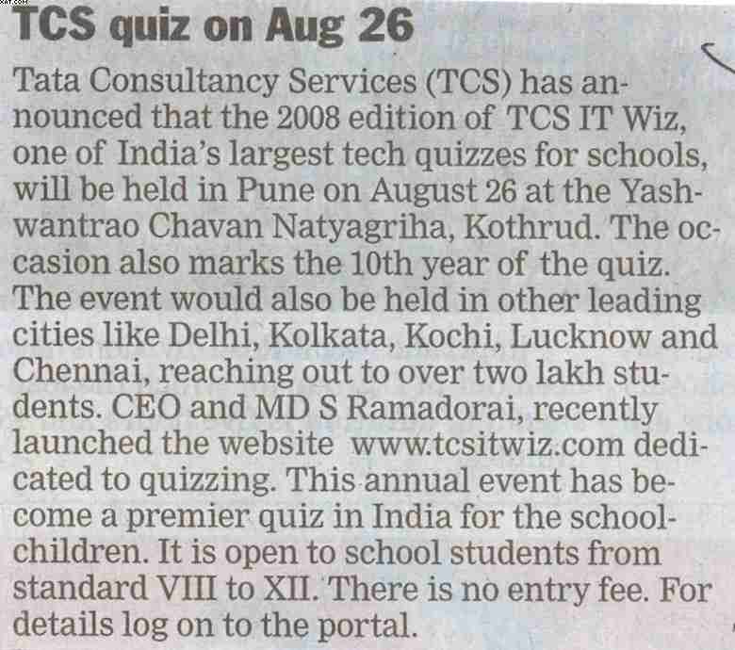

Back to grid

Publication: | Sakal |  | Page 1 of 1
Edition: | Pune
Date: | Aug 17 2008
Page: | 4

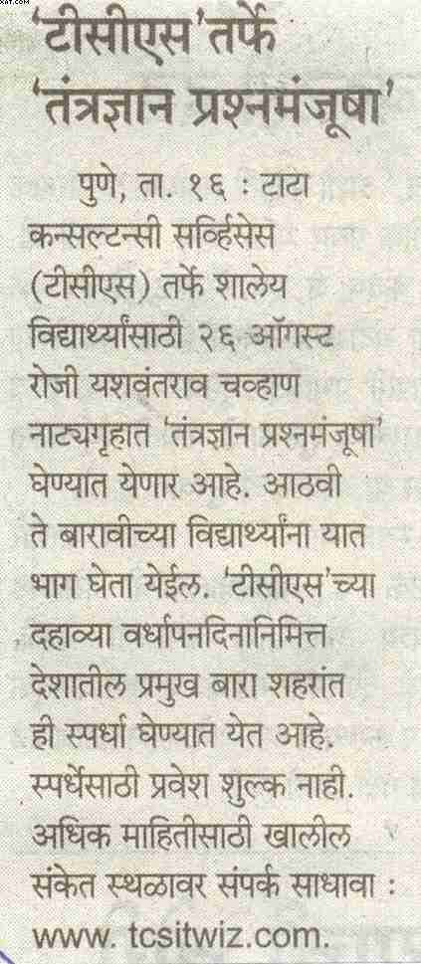

Back to grid

Publication: | Sakal Times |  | Page 1 of 1
Edition: | Pune
Date: | Aug 17 2008
Page: | 2

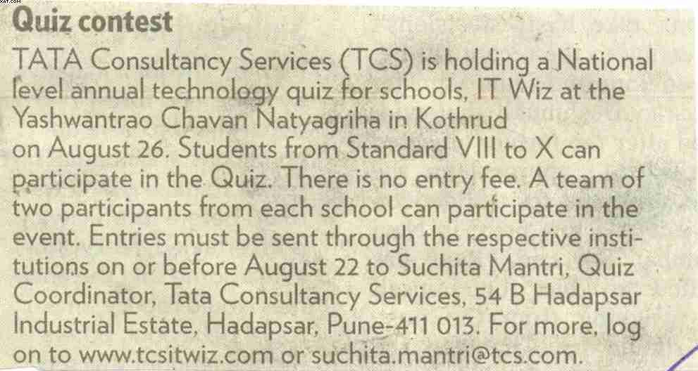

Back to grid

Publication: | Hindu Business Line |  | Page 1 of 1
Edition: | Mumbai
Date: | Aug 26 2008
Page: | 4

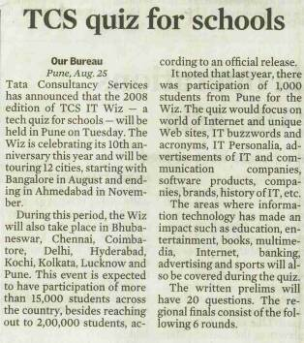

Back to grid

Publication | Sakal |  | Page 1 of 3
Edition | Pune
Date | Aug 27 2008
Page | 2

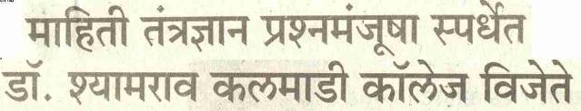

Back to grid | View rest of the clip

Publication | Sakal |  | Page 2 of 3
Edition | Pune
Date | Aug 27 2008
Page | 2

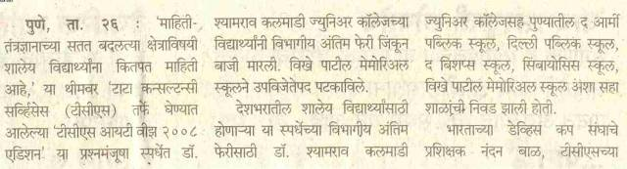

Back to grid | View rest of the clip

Publication | Sakal |  | Page 3 of 3
Edition | Pune
Date | Aug 27 2008
Page | 2

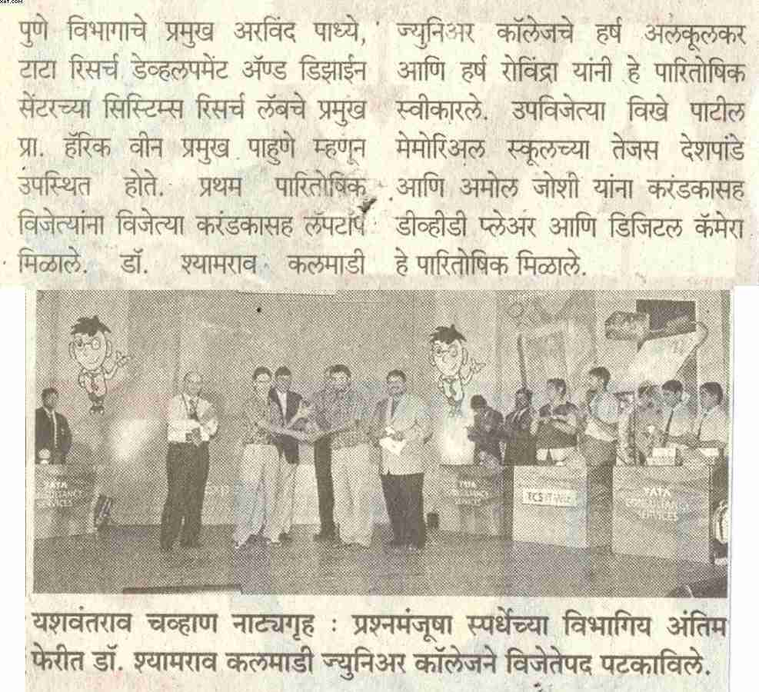

Back to grid

Publication: | Lokmat |  | Page 1 of 1
Edition: | Pune
Date: | Aug 27 2008
Page: | 3

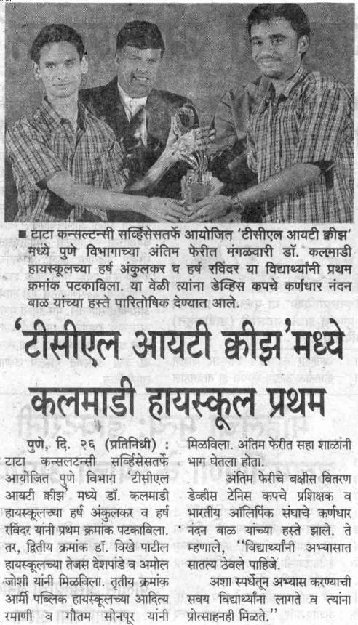

Publication: | The Indian Express |  | Page 1 of 1
Edition: | Pune
Date: | Aug 27 2008
Page: | 8

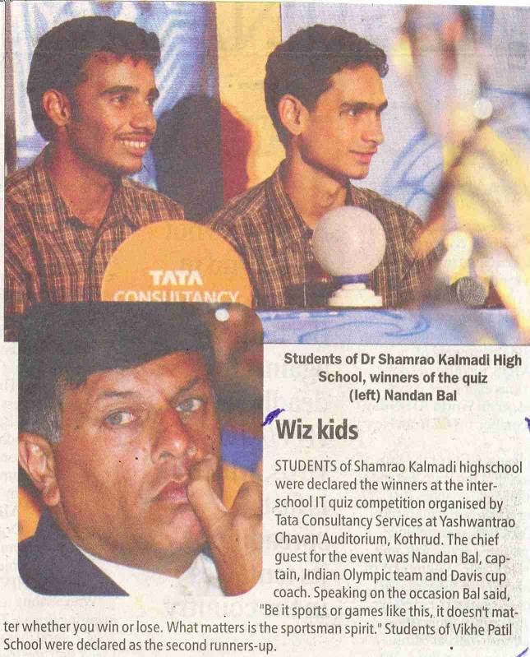

Back to grid

Publication: | The Times of India |  | Page 1 of 1
Edition: | Pune
Date: | Aug 30 2008
Page: | 7

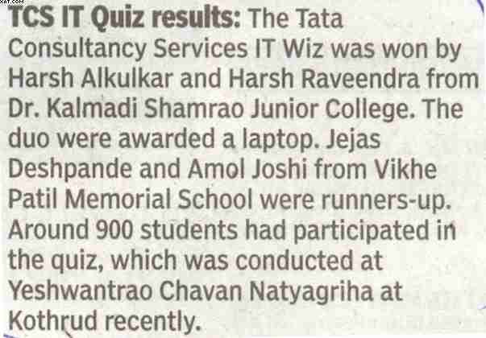

Back to grid

Publication: | Sakal Times |  | Page 1 of 1
Edition: | Pune
Date: | Aug 31 2008
Page: | 3

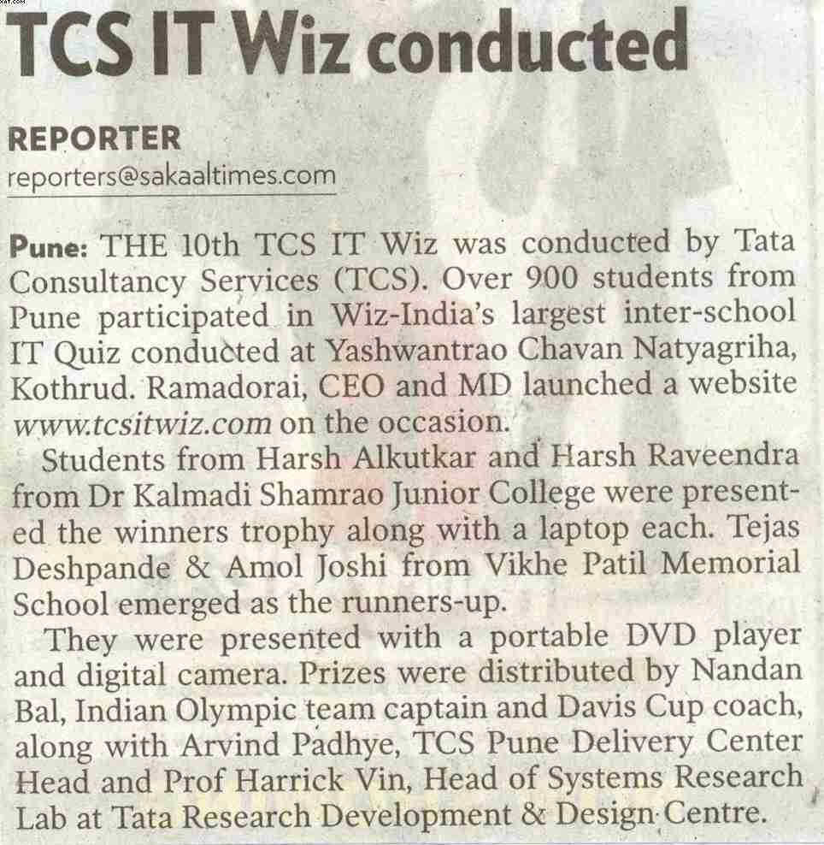

Back to grid

