Coverage Report
TCS IT Wiz 2016
Ahmedabad
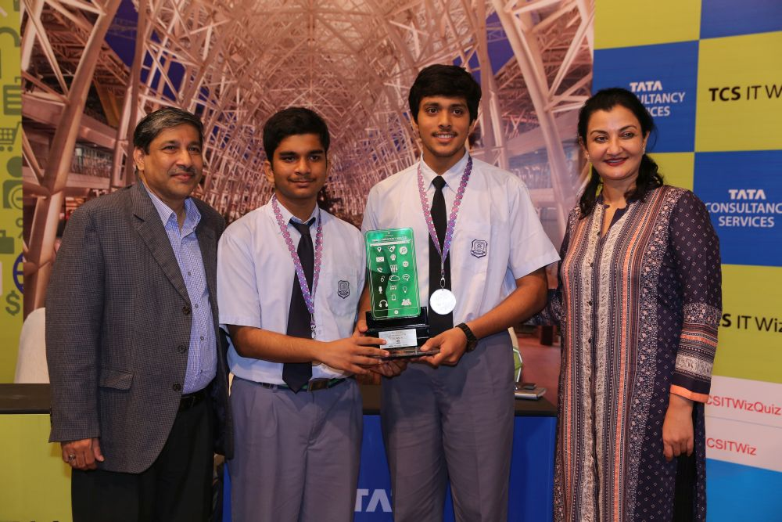

09 August 2016

PRE – EVENT
Date | Article | Publication | Edition | Page No.
03/08/2016 | Ahmedabad to host TCS IT Wiz on August 9th | Standard Herald | Ahmedabad | 11
02/08/2016 | Ahmedabad to host TCS IT Wiz Quiz 2016 | Garv Bhoomi | Ahmedabad | 3
02/08/2016 | Ahmedabad to host TCS IT Wiz Quiz 2016 | Gujarat Pranam | Ahmedabad | 3
02/08/2016 | Ahmedabad to host TCS IT Wiz Quiz 2016 | Lokarpan | Ahmedabad | 3
02/08/2016 | Ahmedabad to host TCS IT Wiz Quiz 2016 | Prabhat | Ahmedabad | 3
30/07/2016 | Quiz competition on 9th August | Divya Bhaskar | Ahmedabad | 1

Publication: Standard Herald
Date: 03/08/2016
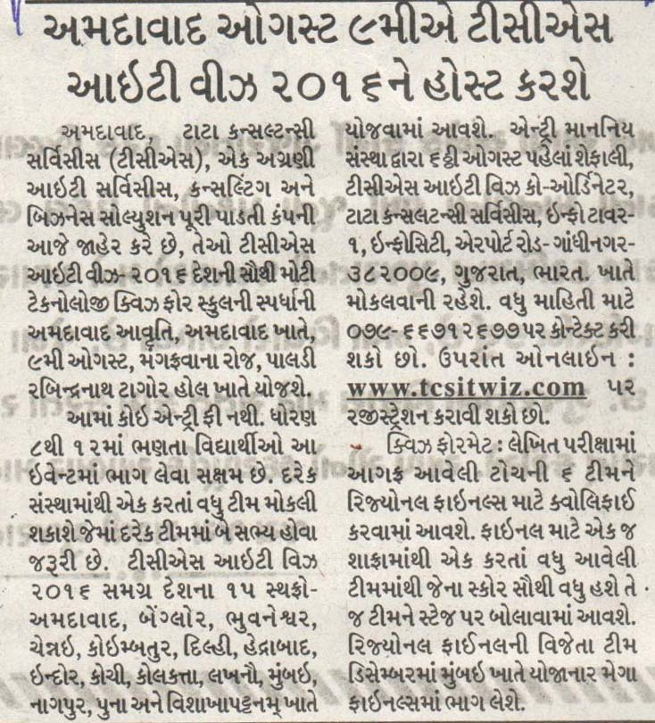
Edition: Ahmedabad
Page No: 11
Headline: Ahmedabad to host TCS IT Wiz on August 9th

Publication: Garv Bhoomi
Date: 02/08/2016
Edition: Ahmedabad
Page No: 3
Headline: Ahmedabad to host TCS IT Wiz Quiz 2016
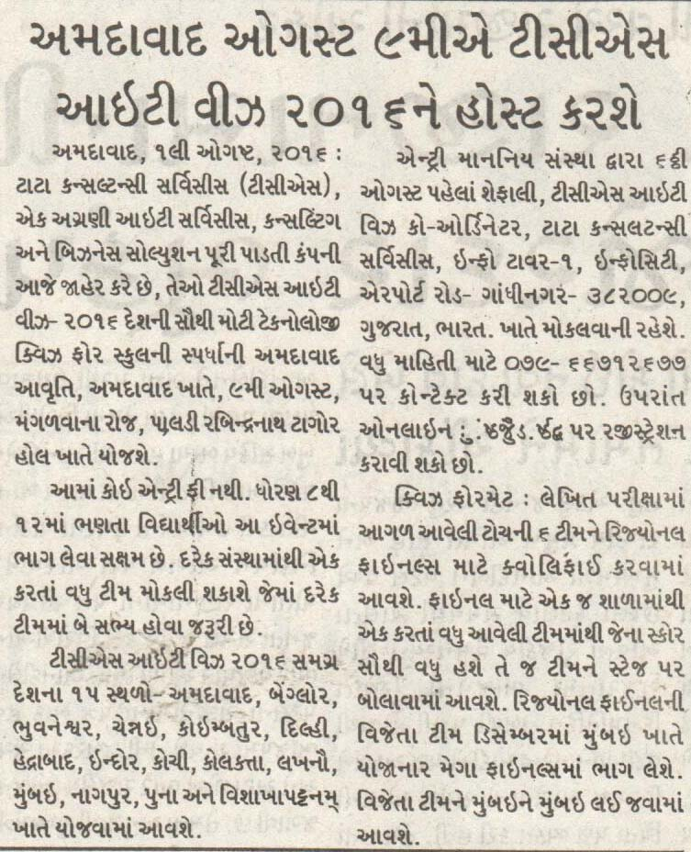

Publication: Gujarat Pranam
Date: 02/08/2016
Edition: Ahmedabad
Page No: 3
Headline: Ahmedabad to host TCS IT Wiz Quiz 2016
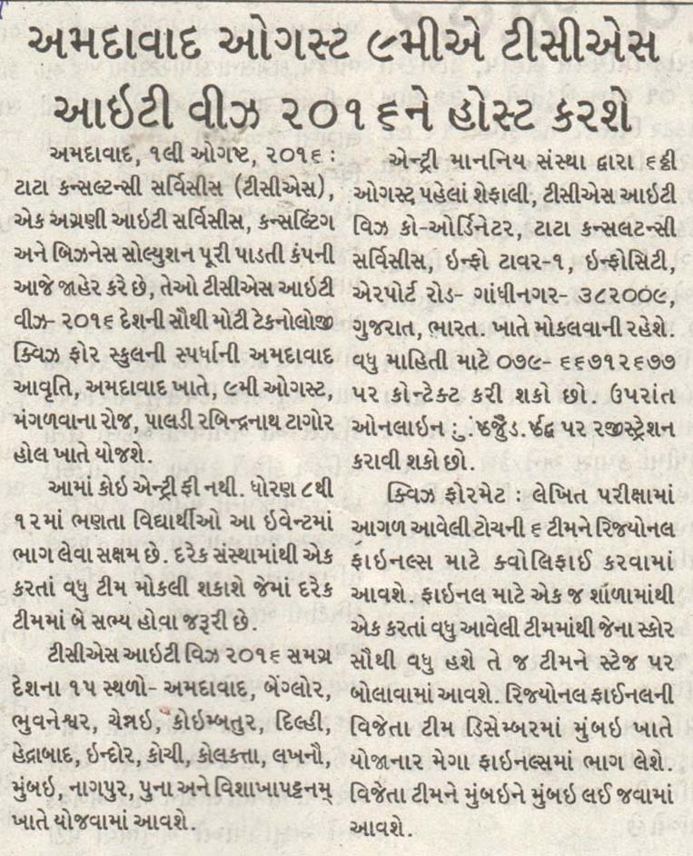

Publication: Lokarpan
Date: 02/08/2016
Edition: Ahmedabad
Page No: 3
Headline: Ahmedabad to host TCS IT Wiz Quiz 2016
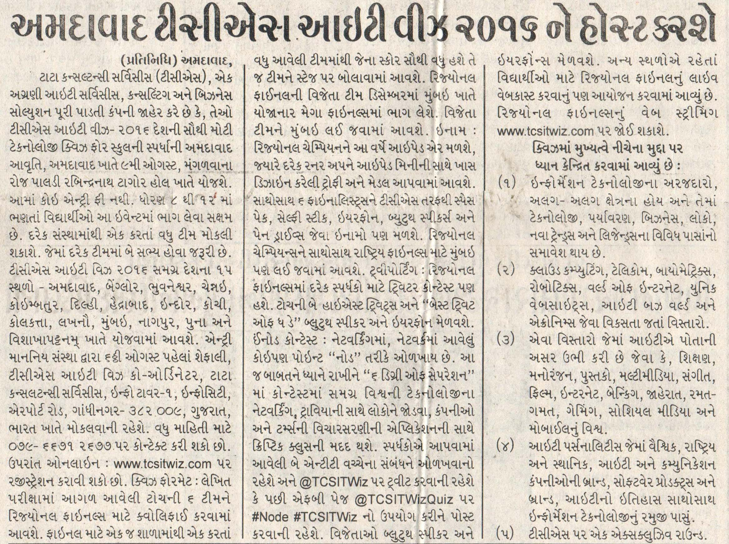

Publication: Prabhat
Date: 02/08/2016
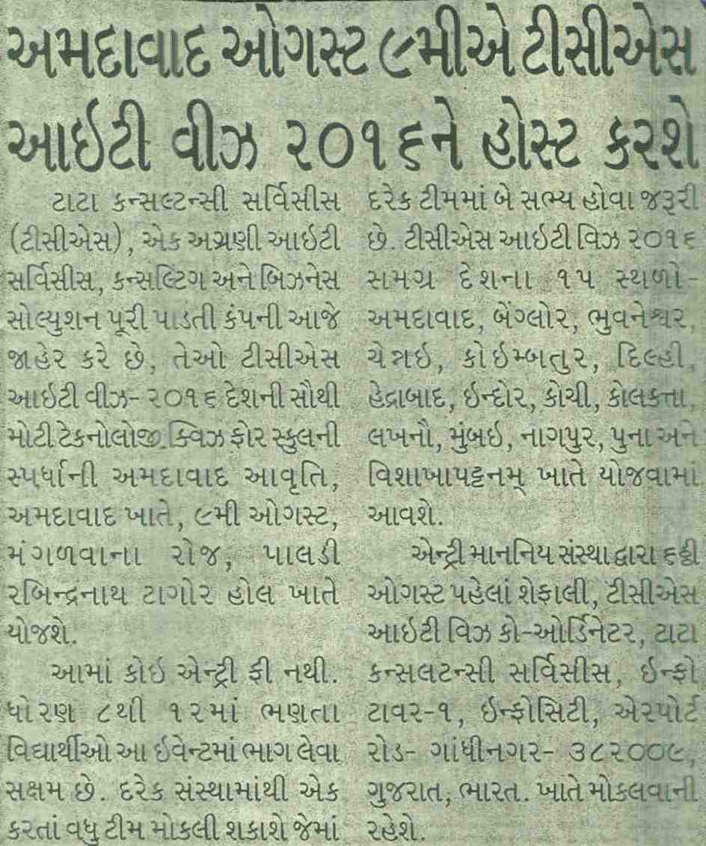
Edition: Ahmedabad
Page No: 3
Headline: Ahmedabad to host TCS IT Wiz Quiz 2016

Publication: Divya Bhaskar
Date: 30/07/2016
Edition: Ahmedabad
Page No: 1
Headline: Quiz competition on 9th August
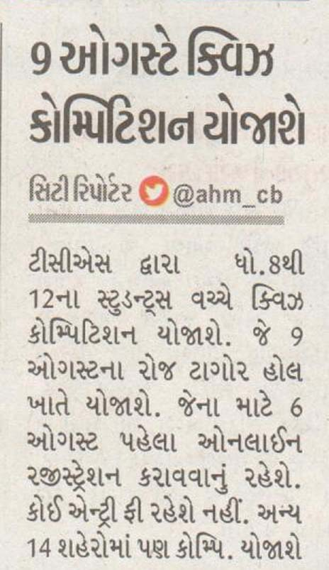

POST – EVENT
Date | Article | Publication | Edition | Page No.
11/08/2016 | Navrachana School, Vadodara becomes winner at TCS IT Wiz 2016 | Satellite Samachar | Ahmedabad | 3
10/08/2016 | Ahmedabad edition of TCS IT Quiz 2016 | Gujarat Niti | Ahmedabad | 5
10/08/2016 | TCS IT Quiz competition | Jai Hind | Ahmedabad | 6
10/08/2016 | TCS IT Quiz competition 2016 | Prabhat | Ahmedabad | 6
10/08/2016 | Navrachana School becomes winner beating Ahmedabad schools | Divya Bhaskar | Ahmedabad | 1
10/08/2016 | Quiz competition held in city | Sandesh | Ahmedabad | 4

Publication: Satellite Samachar
Date: 11/08/2016
Edition: Ahmedabad
Page No: 3
Headline: Navrachana School, Vadodara becomes winner at TCS IT Wiz 2016
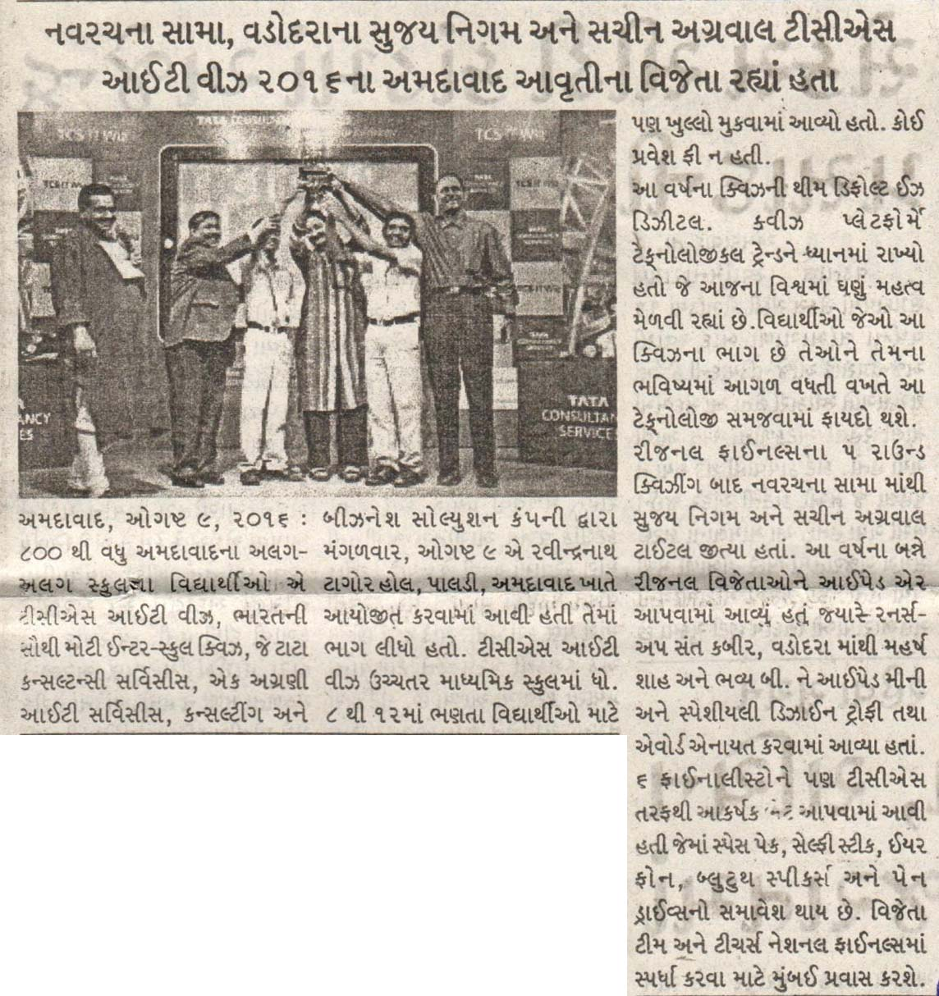

Publication: Gujarat Niti
Date: 10/08/2016
Edition: Ahmedabad
Page No: 5
Headline: Ahmedabad edition of TCS IT Quiz 2016
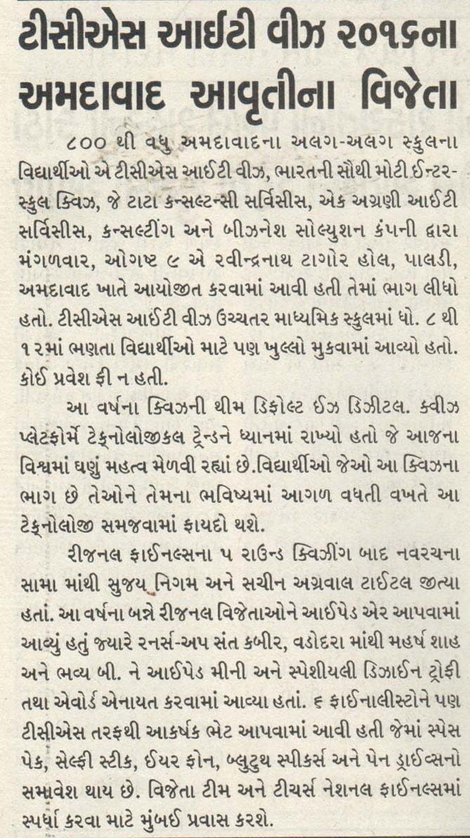

Publication: Jai Hind
Date: 10/08/2016
Edition: Ahmedabad
Page No: 6
Headline: TCS IT Quiz competition
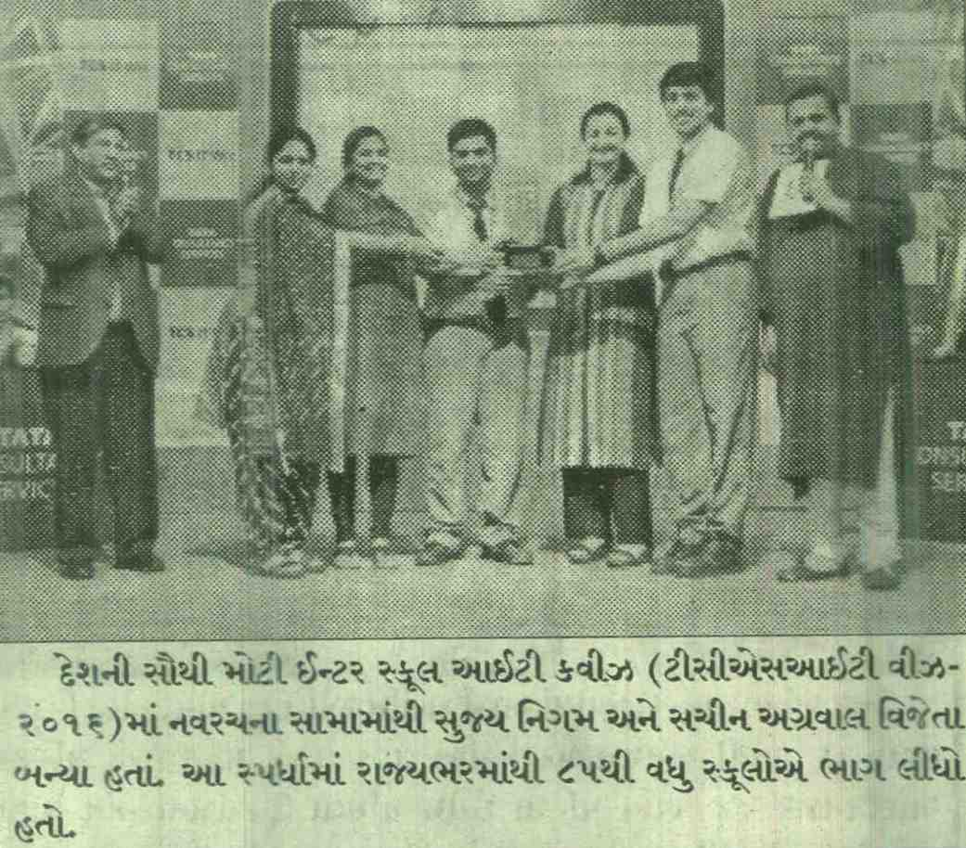
Publication: Prabhat
Date: 10/08/2016
Edition: Ahmedabad
Page No: 6
Headline: TCS IT Quiz competition 2016

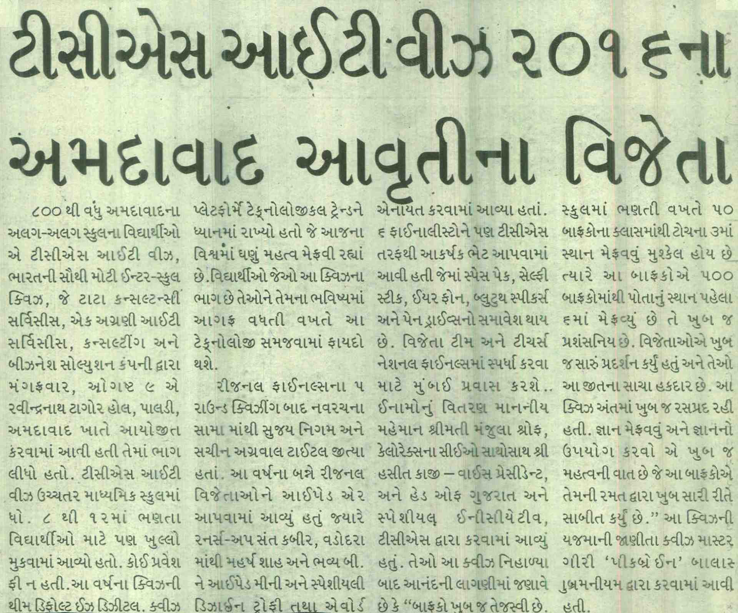

Publication: Divya Bhaskar
Date: 10/08/2016
Edition: Ahmedabad
Page No: 1
Headline: Navrachana School becomes winner beating Ahmedabad schools

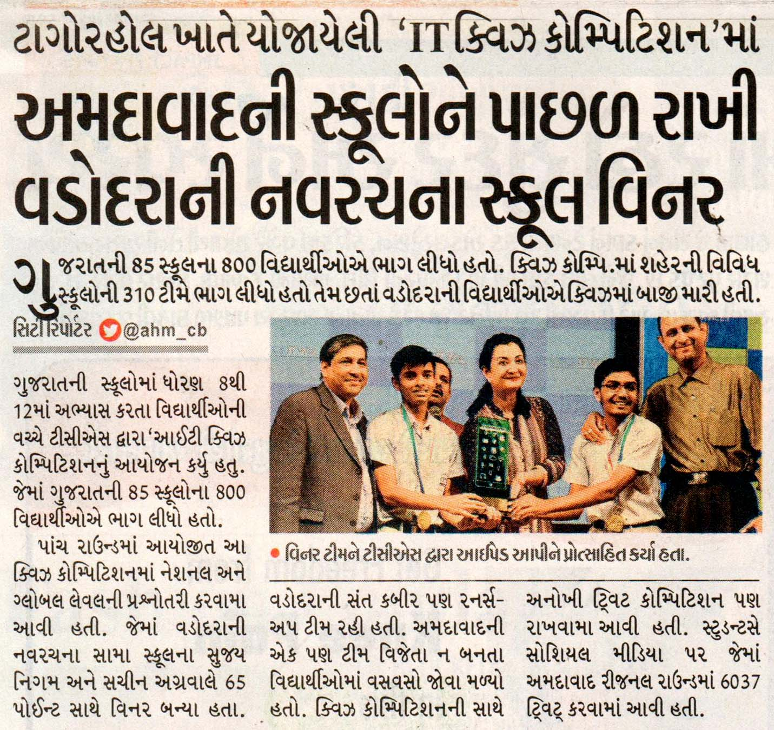
Publication: Sandesh
Date: 10/08/2016
Edition: Ahmedabad
Page No: 4
Headline: Quiz competition held in city
