Coverage Report
TCS IT Wiz 2016
Chennai
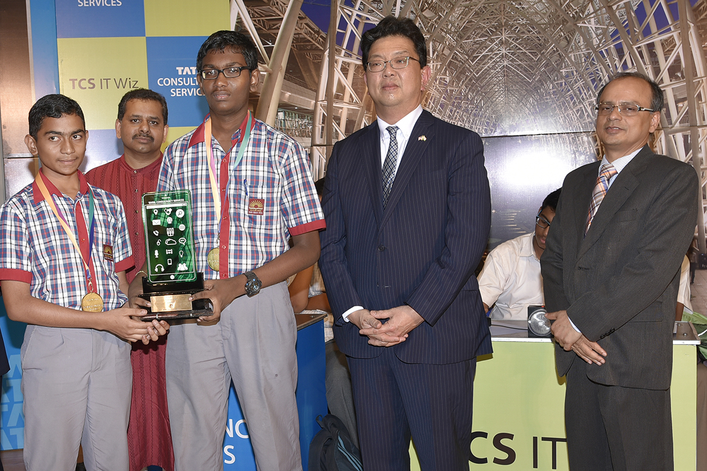

18 August 2016

PRE – EVENT

Date | Article | Publication | Edition | Page No.
18/08/2016 | General | The Hindu | Chennai | 4
18/08/2016 | Today | Deccan Chronicle | Chennai | 18
13/08/2016 | Tech quiz for schools on Aug 18 | DT Next | Chennai | 2
12/08/2016 | It’s quiz time | The Hindu | Chennai | 4
09/08/2016 | TCS to hold Wiz quiz at The Music Academy | The New Indian Express | Chennai | 1

Publication: The Hindu
Date: 18/08/2016
Edition: Chennai
Page No: 4
Headline: General
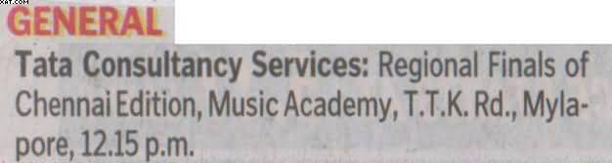

Publication: Deccan Chronicle
Date: 18/08/2016
Edition: Chennai
Page No: 18
Headline: Today
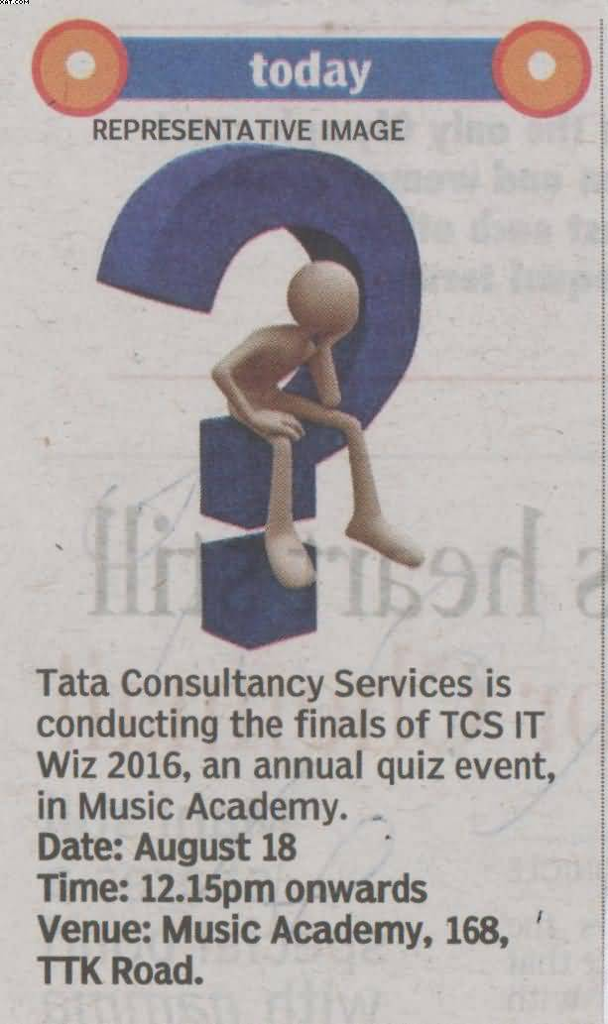

Publication: DT Next
Date: 13/08/2016
Edition: Chennai
Page No: 2
Headline: Tech quiz for schools on Aug 18
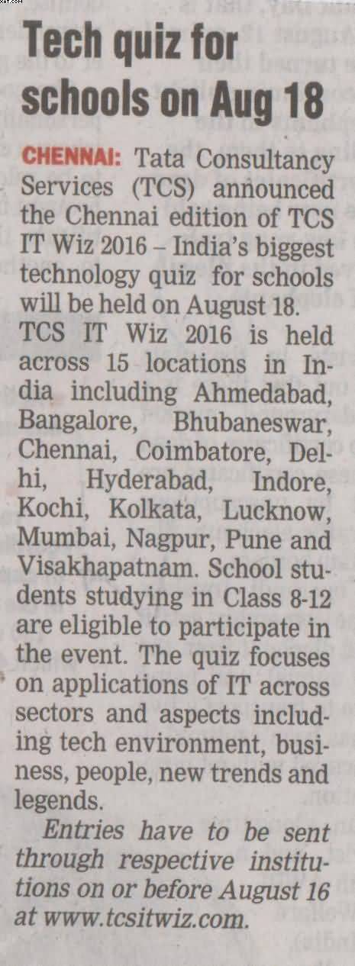

Publication: The Hindu
Date: 12/08/2016
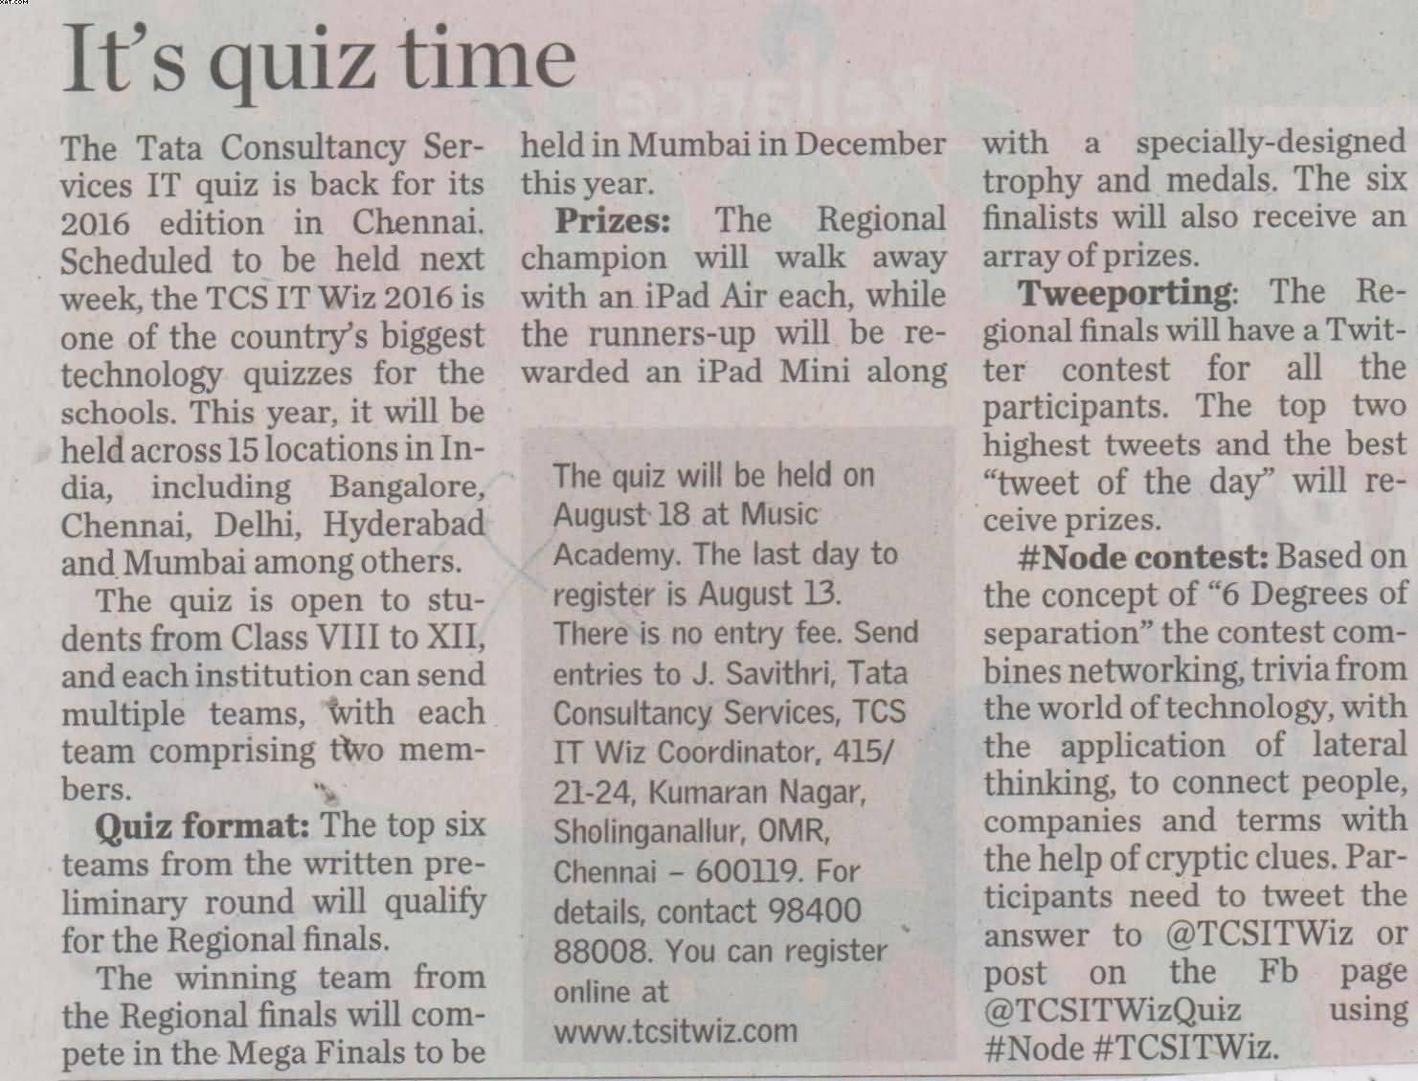
Edition: Chennai
Page No: 4
Headline: It’s quiz time

Publication: The New Indian Express
Date: 09/08/2016
Edition: Chennai
Page No: 1
Headline: TCS to hold Wiz quiz at The Music Academy
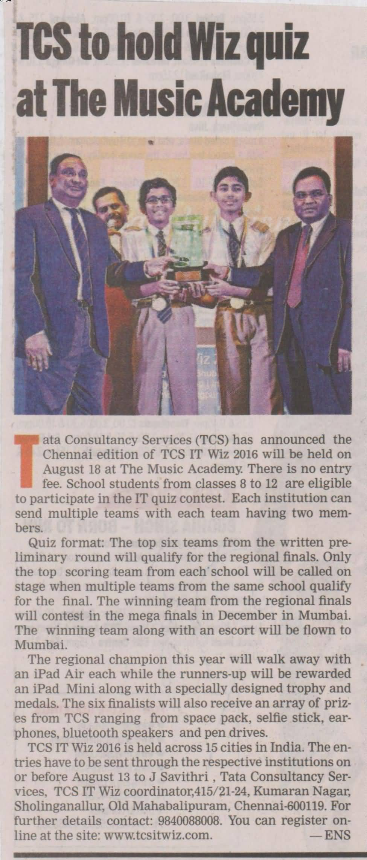

POST – EVENT

Date | Article | Publication | Edition | Page No.
20/08/2016 | Puducherry School wins TCS IT Wiz quiz | The Hindu | Chennai | 4
19/08/2016 | Pondy KV students win TCS quiz contest | Deccan Chronicle | Chennai | 6
19/08/2016 | Puducherry boys win IT Quiz competition | Dina Malar | Chennai | 3

Publication: The Hindu
Date: 20/08/2016
Edition: Chennai
Page No: 4
Headline: Puducherry School wins TCS IT Wiz quiz
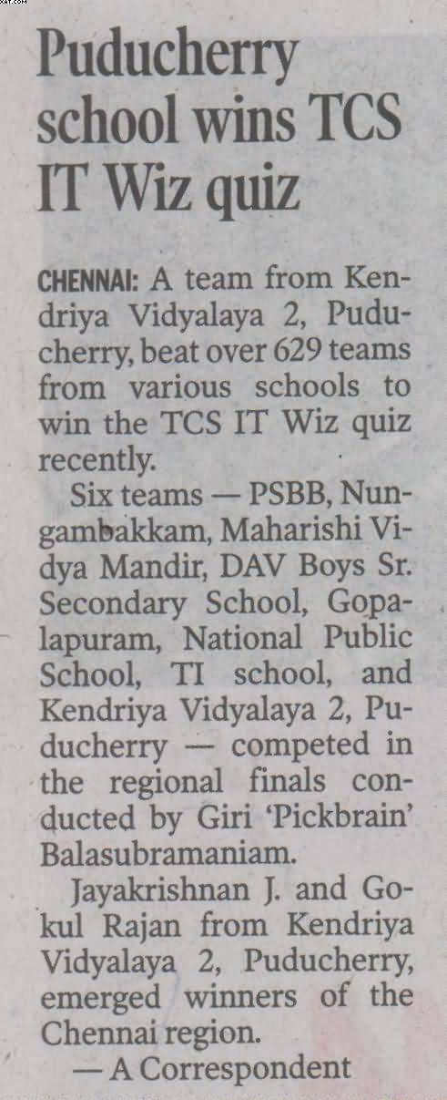
Publication: Deccan Chronicle
Date: 19/08/2016
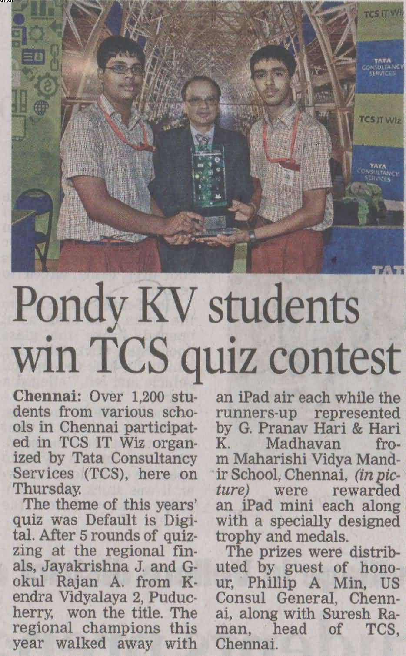
Edition: Chennai
Page No: 6
Headline: Pondy KV students win TCS quiz contest

Publication: Dina Malar
Date: 19/08/2016
Edition: Chennai
Page No: 3
Headline: Puducherry boys win IT Quiz competition
