Coverage Report
TCS IT Wiz 2016
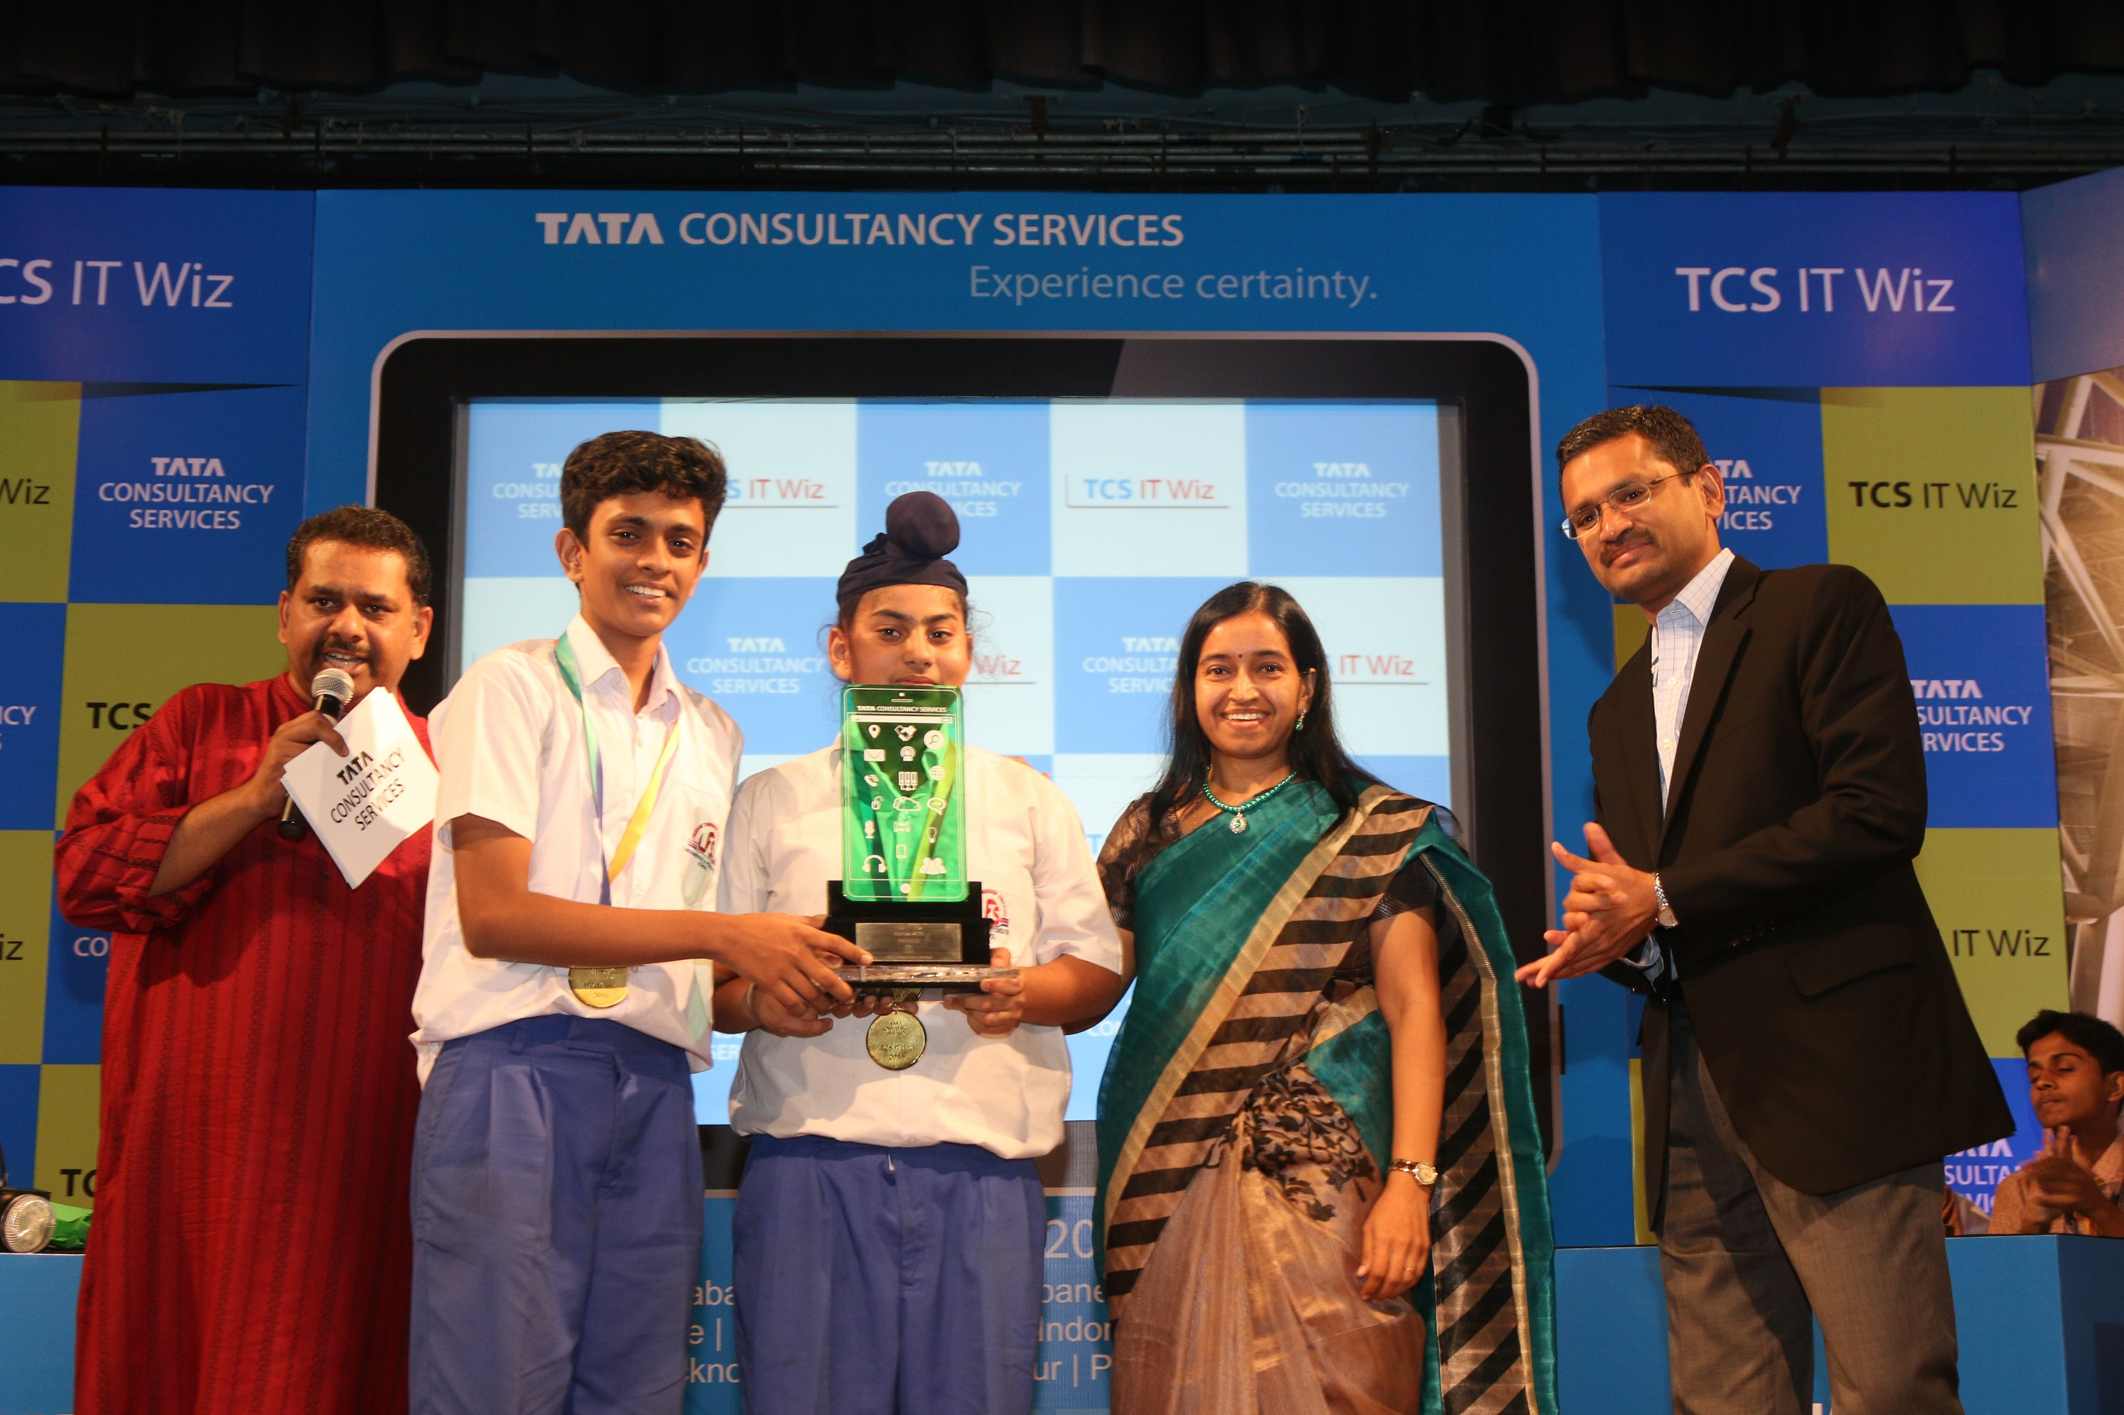
Mumbai

23 October 2016

POST – EVENT

Date | Article | Publication | Edition | Page No.
10/11/2016 | Lokhandwala Foundation School wins. | Punya Nagari | Mumbai | 7
06/11/2016 | Lokhandwala Foundation School wins | Divya Bhaskar | Mumbai | 3
25/10/2016 | TCS Information Technology contest | Prahar | Mumbai | 2

Publication: Punya Nagari
Date: 10/11/2016
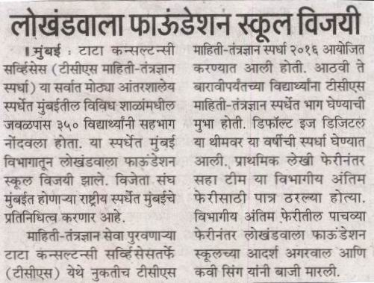
Edition: Mumbai
Page No: 7
Headline: Lokhandwala Foundation School wins

Publication: Divya Bhaskar
Date: 06/11/2016
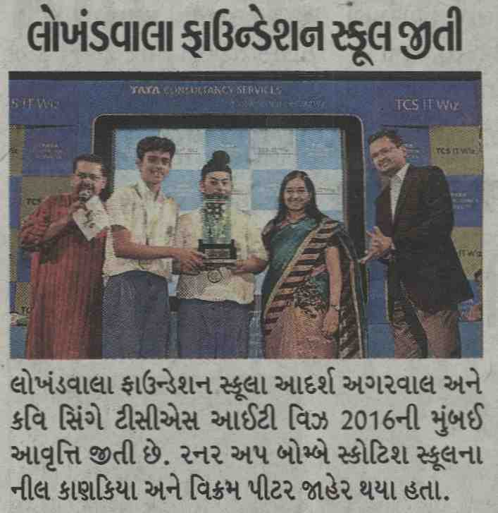
Edition: Mumbai
Page No: 3
Headline: Lokhandwala Foundation School wins

Publication: Prahar
Date: 25/10/2016
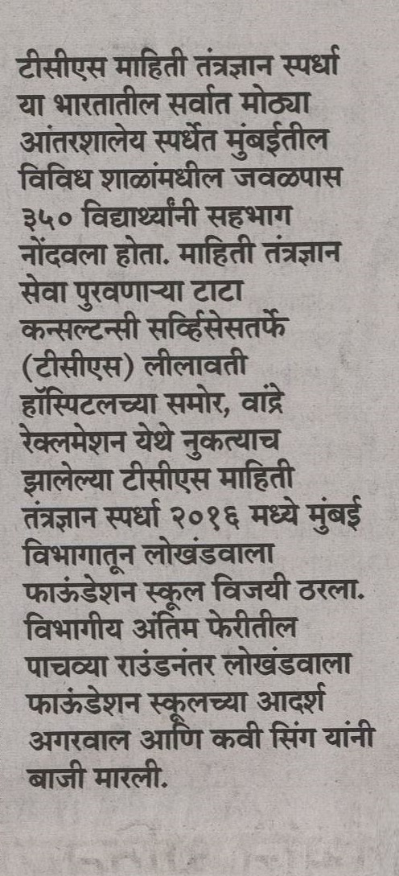
Edition: Mumbai
Page No: 2
Headline: TCS Information Technology contest

