Article Date | Headline / Summary | Publication | Edition | Page No. | Journalist
Regional
3 Aug 2017 | Sama Vadodara crowned winners of TCS IT Wiz Ahmedabad Edition | Free Press Gujarat | Ahmedabad | 2 | Bureau
3 Aug 2017 | Navrachna Sama school became a winner of TCS quiz competition, Ahmedabad Edition | Alpviram Ahmedabad | Ahmedabad | 7 | Bureau
3 Aug 2017 | Navrachna Sama school became a winner of TCS quiz competition, Ahmedabad Edition | Standard Herald | Ahmedabad | 11 | Bureau
2 Aug 2017 | St. Kabir school is runner up in IT Quiz | Divya Bhaskar | Ahmedabad | 1 | Bureau
2 Aug 2017 | navrachna Sama school became a winner of TCS quiz competition, Ahmedabad Edition | Gujarat Pranam | Ahmedabad | 7 | Bureau
2 Aug 2017 | navrachna sama school became a winner of TCS quiz competition, Ahmedabad Edition | Lokmitra | Ahmedabad | 2 | Bureau
2 Aug 2017 | navrachna sama school became a winner of TCS quiz competition, Ahmedabad Edition | Satellite Samachar | Ahmedabad | 3 | Bureau
2 Aug 2017 | navrachna sama school became a winner of TCS quiz competition, Ahmedabad Edition | Tofani Kanudo | Ahmedabad | 3 | Bureau

Regional

Published Date: | 3 Aug 2017 | Publication: | Free Press Gujarat
Edition: | Ahmedabad | Page No: | 2
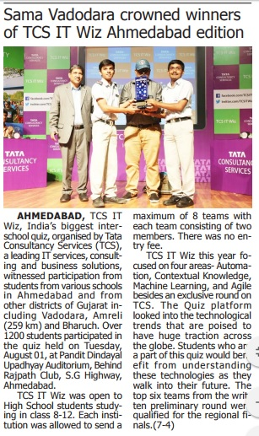

Published Date: | 3 Aug 2017 | Publication: | Alpviram Ahmedabad
Edition: | Ahmedabad | Page No: | 7
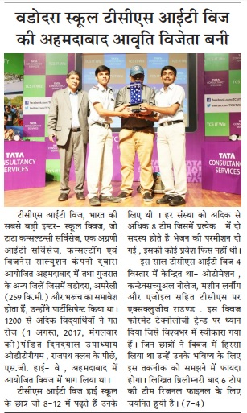

Published Date: | 3 Aug 2017 | Publication: | Standard Herald
Edition: | Ahmedabad | Page No: | 11
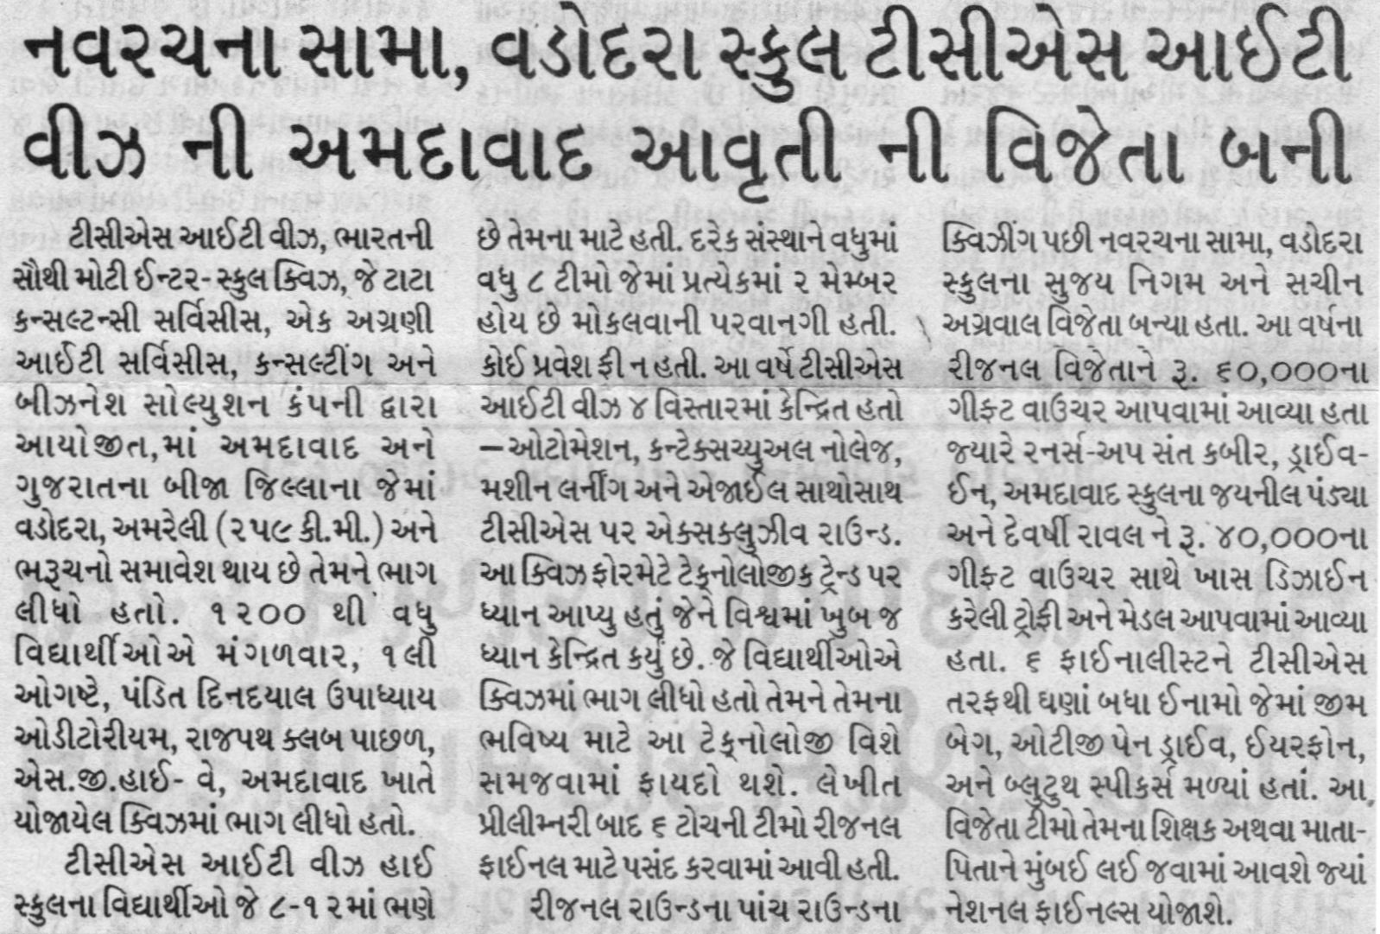
Published Date: | 2 Aug 2017 | Publication: | Divya Bhaskar (Gujarati)
Edition: | Ahmedabad | Page No: | 1

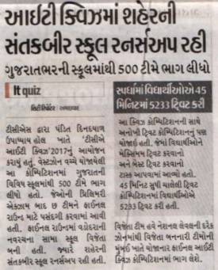

Published Date: | 2 Aug 2017 | Publication: | Gujarat Pranam (Gujarati)
Edition: | Ahmedabad | Page No: | 7

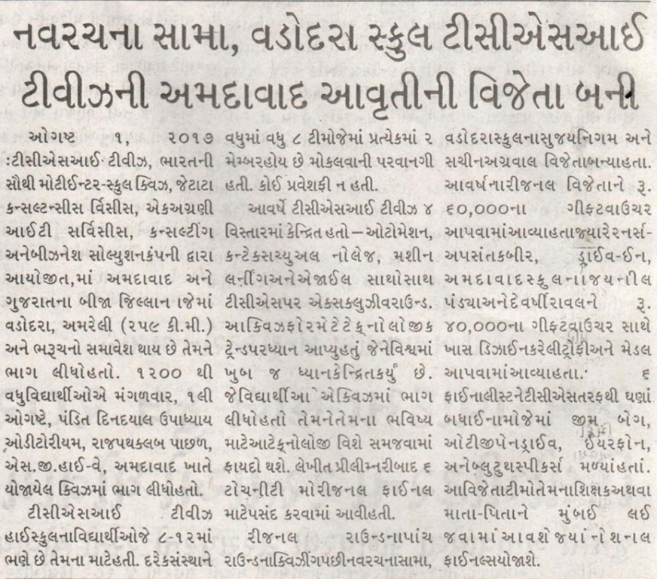

Published Date: | 2 Aug 2017 | Publication: | Lokmitra (Gujarati)
Edition: | Ahmedabad | Page No: | 2

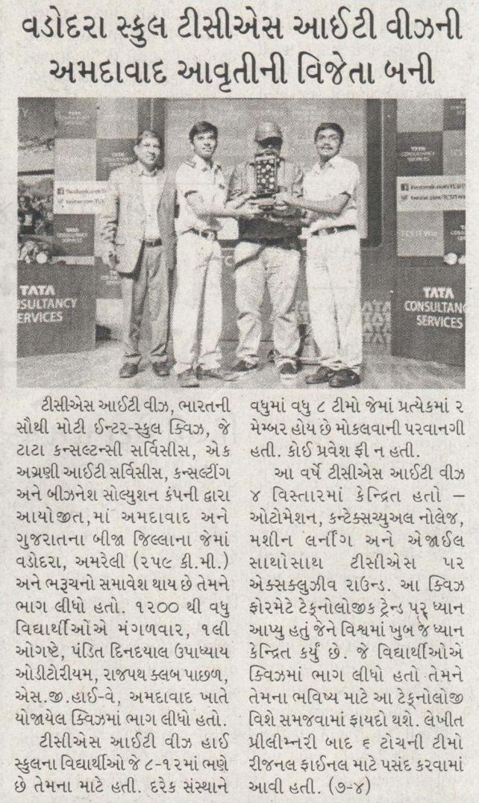

Published Date: | 2 Aug 2017 | Publication: | Satellite Samachar (Gujarati)
Edition: | Ahmedabad | Page No: | 3

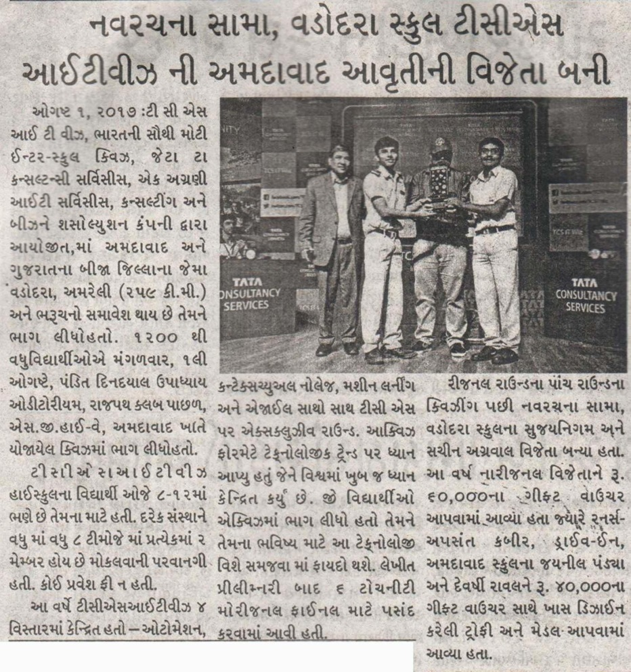

Published Date: | 2 Aug 2017 | Publication: | Tofani Kanudo (Gujarati)
Edition: | Ahmedabad | Page No: | 3

