Article Date | Headline | Publication | Edition | Page No. | Journalist
Print
20th July 2017 | TCS IT Wiz 2017 Ahmedabad edition on August 1 | Lokmitra | Ahmedabad | 3 | Bureau
21st July 2017 | TCS IT Wiz 2017 Ahmedabad edition on August 1 | Gujarat Niti | Ahmedabad | 7 | Bureau
27th July 2017 | TCS IT WIZ 2017 on Aug 1 | DNA | Ahmedabad | 3 | Bureau

Print

Publication: | Lokmitra | Edition: | Ahmedabad
Published Date: | 20 July 2017 | Page No.: | 3
 |  | Display: | 1/1

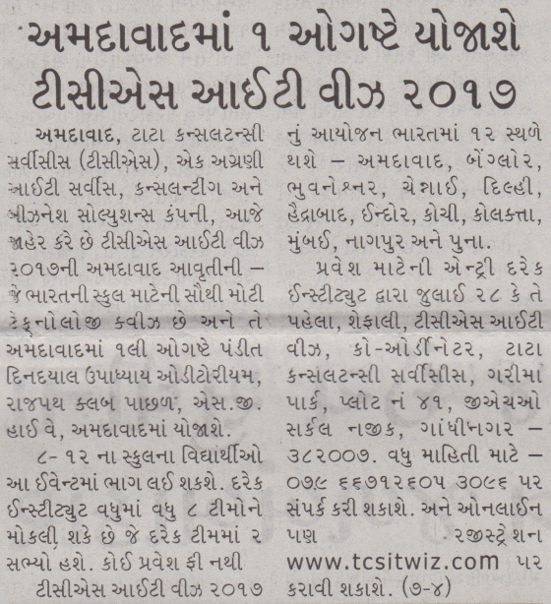

Publication: | Gujarat Niti | Edition: | Ahmedabad
Published Date: | 21 July 2017 | Page No.: | 7
 |  | Display: | 1/1

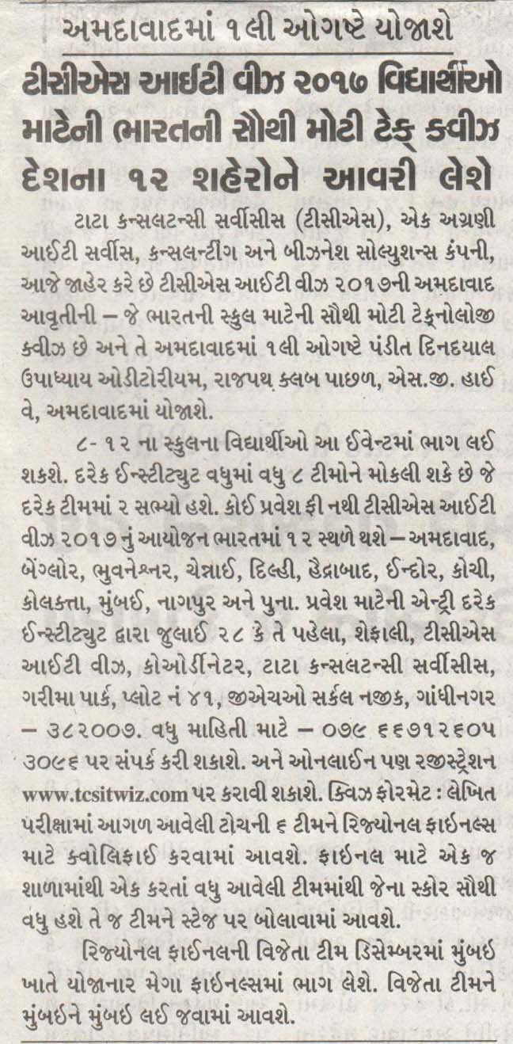

Publication: | DNA | Edition: | Ahmedabad
Published Date: | 27 July 2017 | Page No.: | 3
 |  | Display: | 1/1

