Coverage Report
TCS IT Wiz 2017
Bengaluru
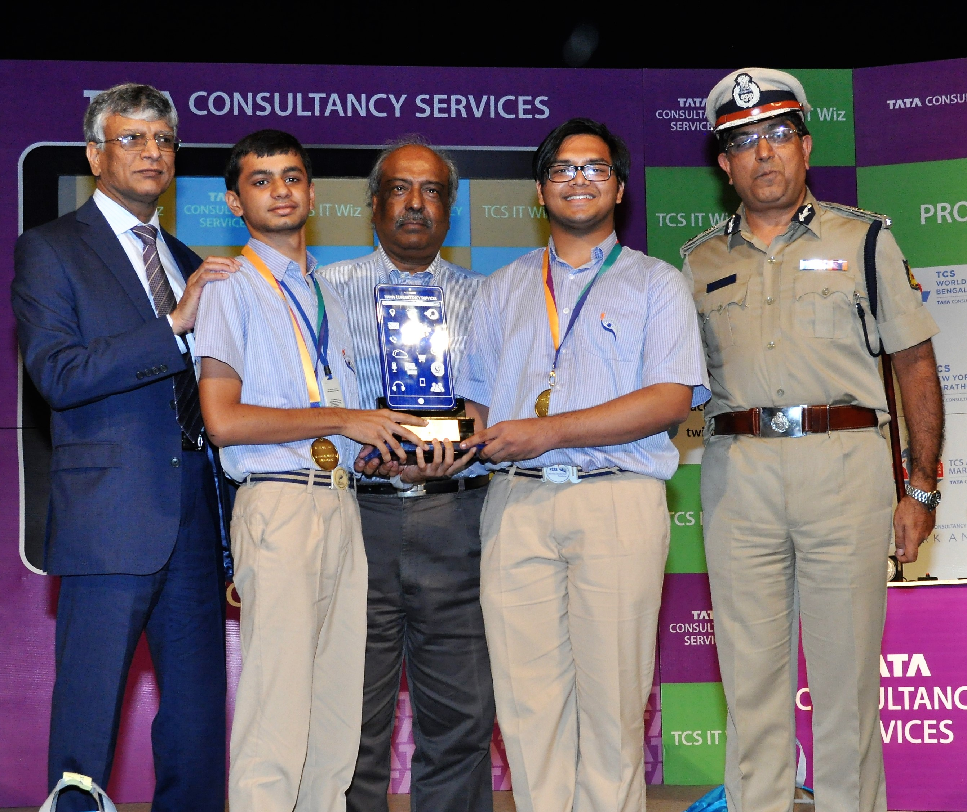
03 August 2017

POST – EVENT
Date | Article | Publication | Edition | Page No.
4 Aug 2017 | Padma Seshadri boys win TCS IT quiz, head to finals | The Times of India | Bangalore | 6
4 Aug 2017 | PSSB wins TCS regional round quiz | Deccan Herald | Bangalore | 4
4 Aug 2017 | PSSB student wins | Vijay Karnataka | Bangalore | 4
4 Aug 2017 | Quiz Competition: PSSB student wins | Prajavani | Bangalore | 3
4 Aug 2017 | PSSB student wins TCS IT WIZ | Vishwavani | Bangalore | 2
4 Aug 2017 | Aryan and Pranav wins | Hosadigantha | Bangalore | 2
4 Aug 2017 | PSSB student wins | Eenadu | Bangalore | 5
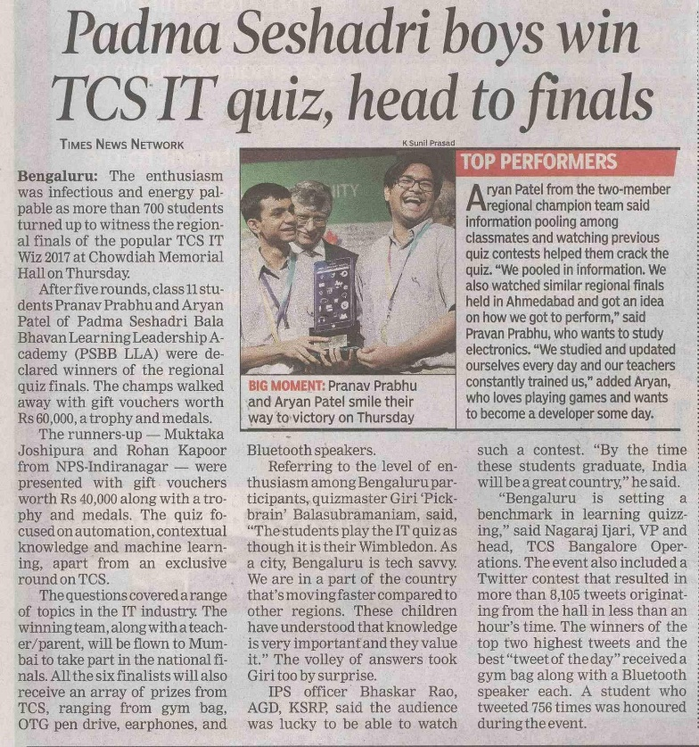
Published Date: | 4 Aug 2017 | Publication: | The Times of India
Edition: | Bangalore | Page No: | 6

1/1 | Back To Index

Published Date: | 4 Aug 2017 | Publication: | Deccan Herald
Edition: | Bangalore | Page No: | 4
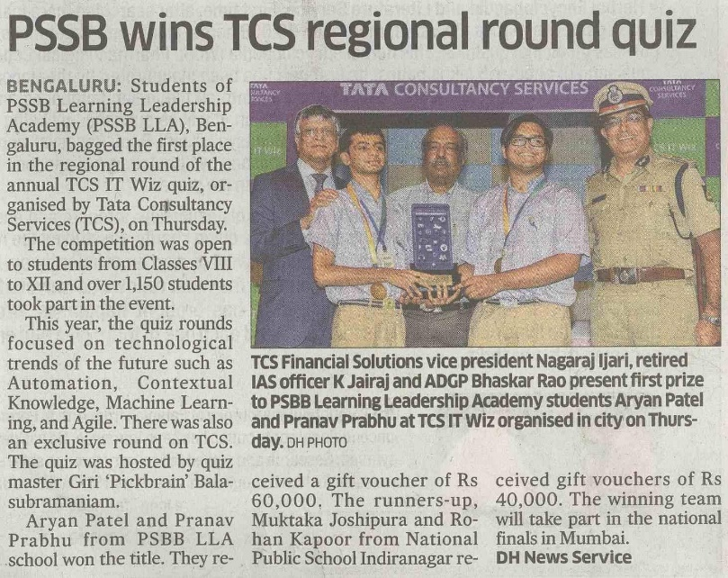

1/1 | Back To Index

Published Date: | 4 Aug 2017 | Publication: | Vijay Karnataka
Edition: | Bangalore | Page No: | 4
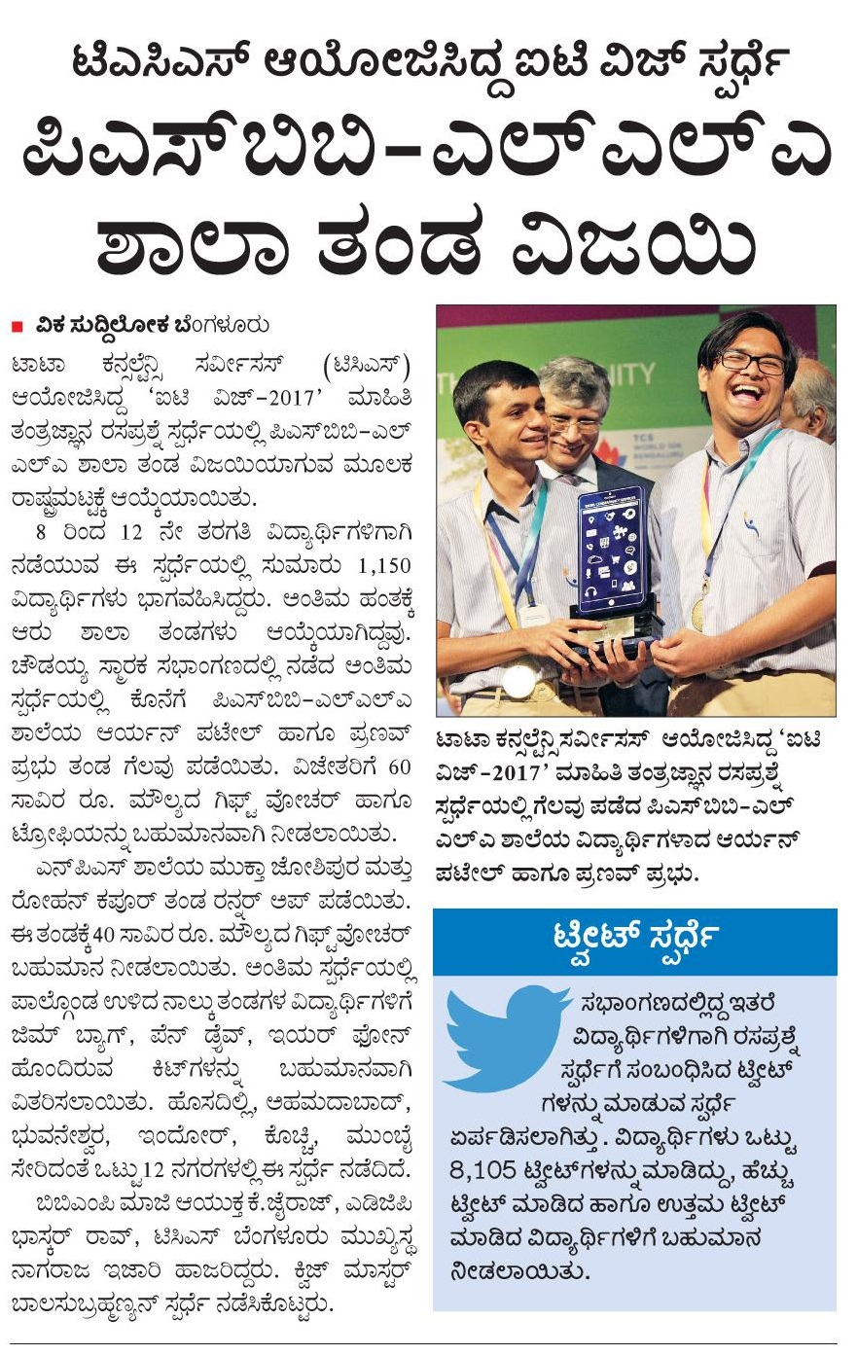

Published Date: | 4 Aug 2017 | Publication: | Prajavani
Edition: | Bangalore | Page No: | 3
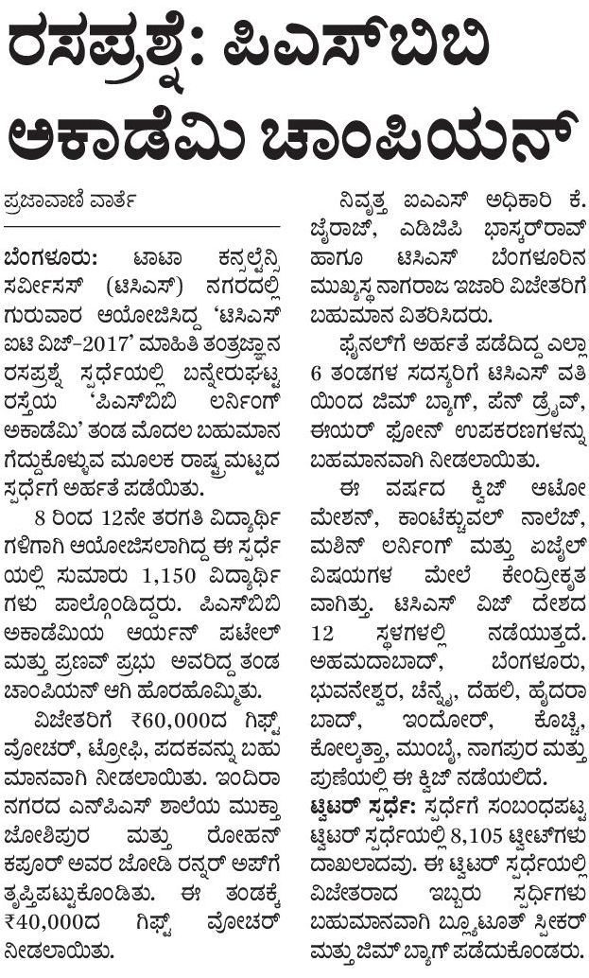

Published Date: | 4 Aug 2017 | Publication: | Vishwavani
Edition: | Bangalore | Page No: | 2

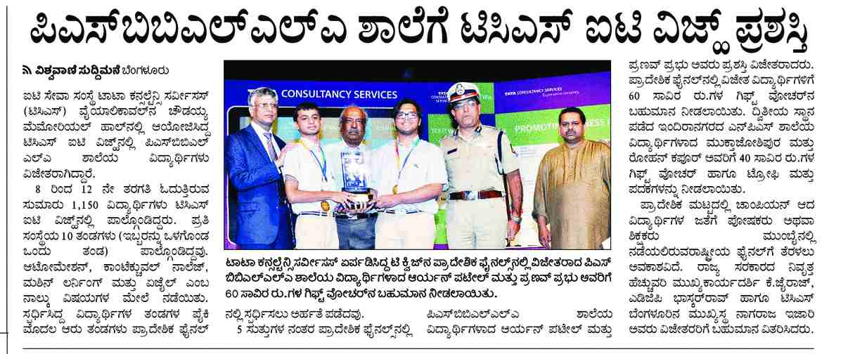

Published Date: | 4 Aug 2017 | Publication: | Hosadigantha
Edition: | Bangalore | Page No: | 2
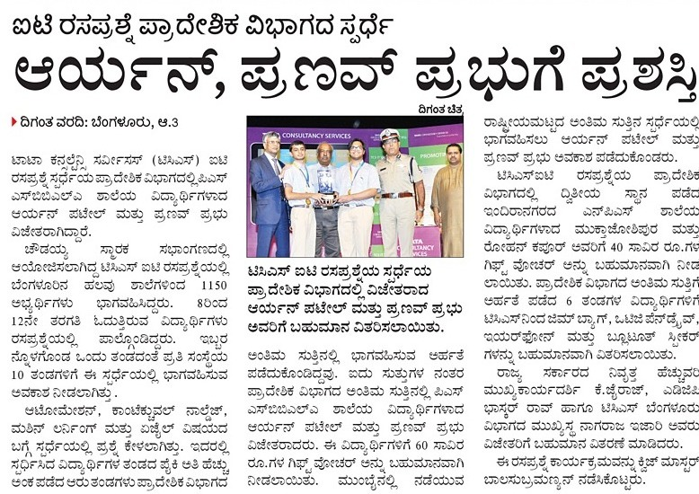

Published Date: | 4 Aug 2017 | Publication: | Eenadu
Edition: | Bangalore | Page No: | 5



