Article Date | Headline | Publication | Edition | Page No. | Journalist
Print
18 July 2017 | Entries invited for TCS IT WIZ contest | Deccan Herald | Bangalore | 2 | Bureau
21st July | IT Quiz competition | The Hindu | Bangalore | 2 | Sudheendra
Regional
22 July 2017 | IT wiz on August 3rd | Prajavani | Bangalore | 3 | Bureau
22 July 2017 | TCS IT Wiz 2017 on August 3 at Vyalikaval | Kannada Prabha | Bangalore | 4 | Bureau
22 July 2017 | TCS IT WIZ | Vijayakarnataka | Bangalore | 8 | Bureau
23 July 2017 | TCS IT Wiz Quiz on Aug 3 | Vijayakarnataka | Bangalore | 8 | Bureau
24 July 2017 | TCS IT Wiz Quiz on Aug 3 | Vijayavani | Bangalore | 3 | Bureau
Online
18 July 2017 | Entries invited for TCS IT WIZ contest | Deccan Herald | Bangalore | Online | Bureau
21st July | IT Quiz competition | The Hindu | Bangalore | Online | Sudheendra

Print

Publication: | Deccan Herald | Edition: | Bangalore
Published Date: | 18 July 2017 | Page No.: | 2
 |  | Display: | 1/1

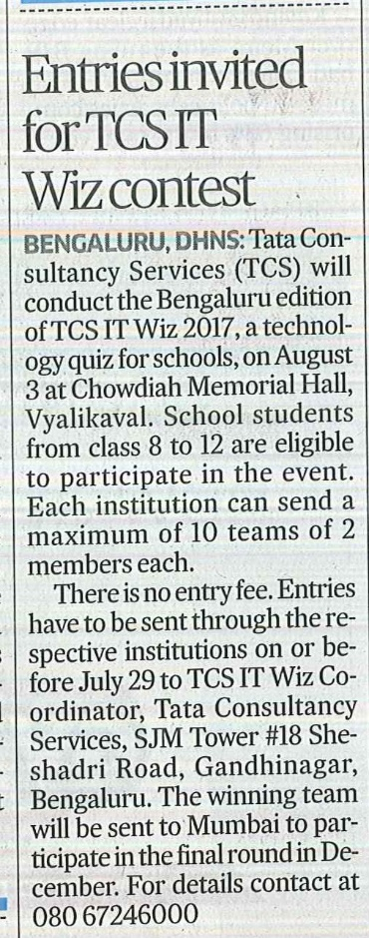

Publication: | The Hindu | Edition: | Bangalore
Published Date: | 21 July 2017 | Page No.: | 2
 |  | Display: | 1/1

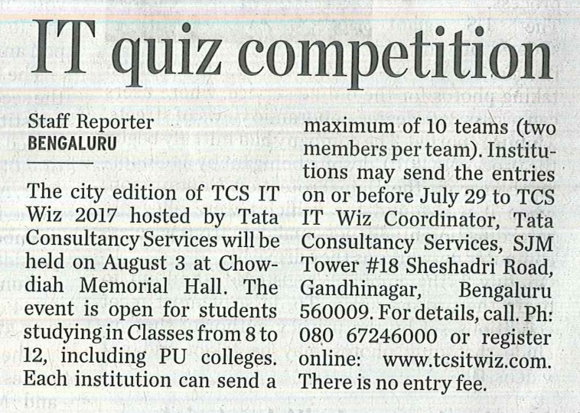

Regional

Publication: | Prajavani | Edition: | Bangalore
Published Date: | 22 July 2017 | Page No.: | 3
 |  | Display: | 1/1

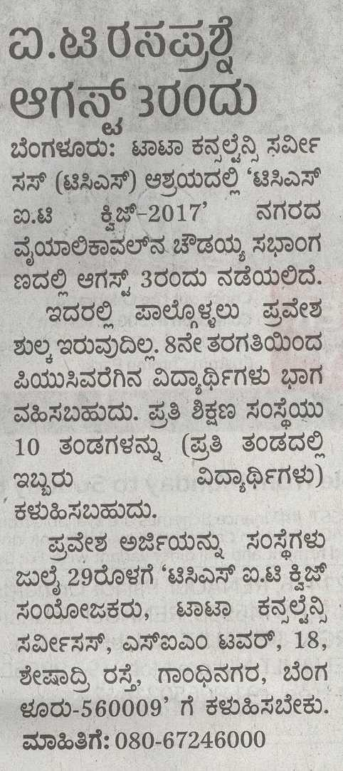

Publication: | Kannada Prabha | Edition: | Bangalore
Published Date: | 22 July 2017 | Page No.: | 4
 |  | Display: | 1/1
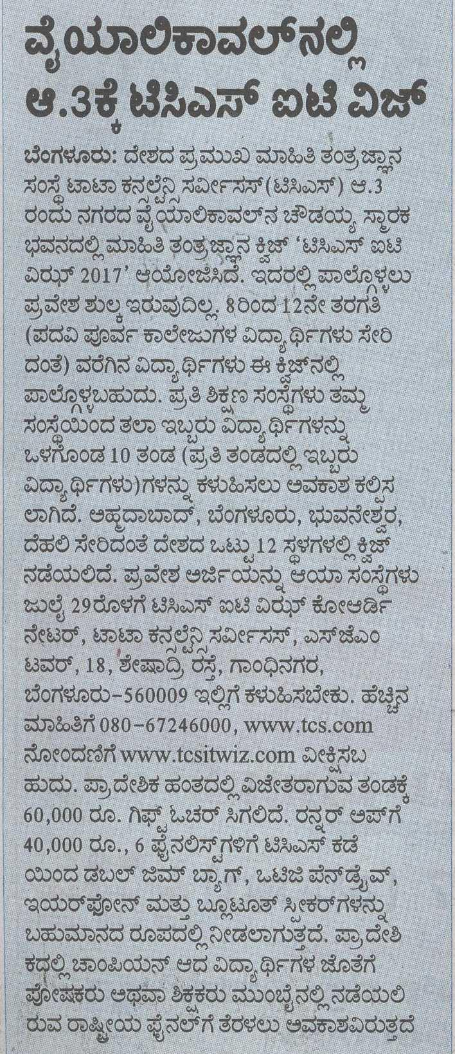

Publication: | Vijayakarnataka | Edition: | Bangalore
Published Date: | 22 July 2017 | Page No.: | 8
 |  | Display: | 1/1
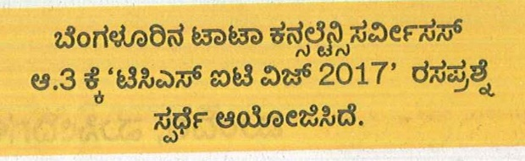

Publication: | Vijayakarnataka | Edition: | Bangalore
Published Date: | 23 July 2017 | Page No.: | 8
 |  | Display: | 1/1
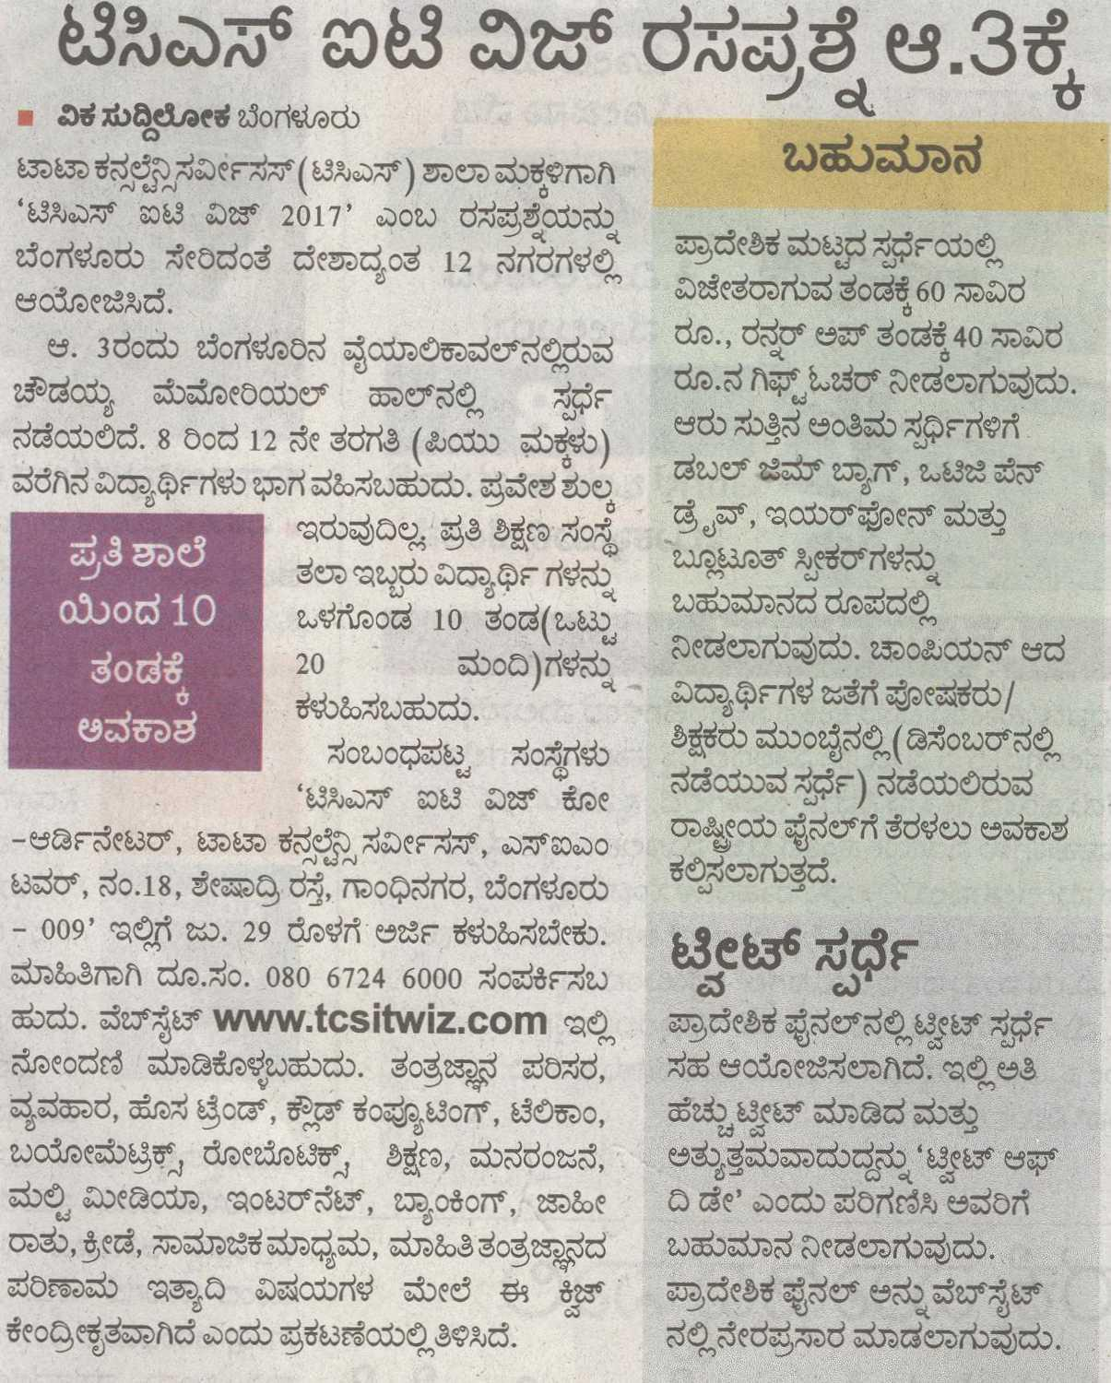

Publication: | Vijayavani | Edition: | Bangalore
Published Date: | 24 July 2017 | Page No.: | 3
 |  | Display: | 1/1

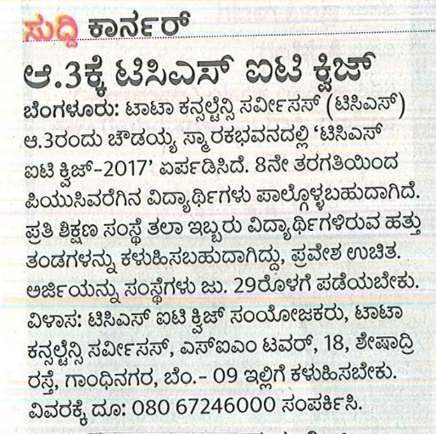

Online

Publication: | Deccan Herald | Edition: | Bangalore
Published Date: | 18 July 2017 | Page No.: | Online
 |  | Display: | 1/1

Entries invited for TCS IT Wiz contest
DH News Service, Bengaluru, Jul 18 2017, 2:38 IST
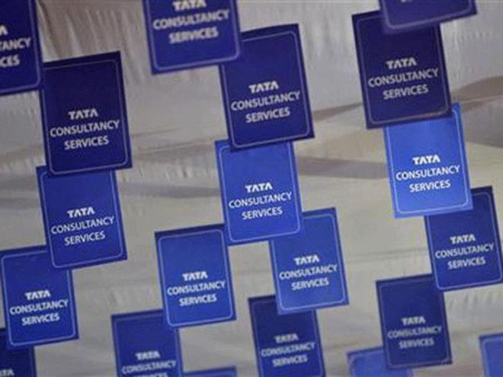
Tata Consultancy Services (TCS) will conduct the Bengaluru edition of TCS IT Wiz 2017, a technology quiz for schools, on August 3 at Chowdiah Memorial Hall, Vyalikaval. Reuters file photo

Tata Consultancy Services (TCS) will conduct the Bengaluru edition of TCS IT Wiz 2017, a technology quiz for schools, on August 3 at Chowdiah Memorial Hall, Vyalikaval. School students from class 8 to 12 are eligible to participate in the event. Each institution can send a maximum of 10 teams of 2 members each.
There is no entry fee. Entries have to be sent through the respective institutions on or before July 29 to TCS IT Wiz Coordinator, Tata Consultancy Services, SJM Tower #18 Sheshadri Road, Gandhinagar, Bengaluru. The winning team will be sent to Mumbai to participate in the final round in December. For details contact at 080 67246000

Publication: | The Hindu | Edition: | Bangalore
Published Date: | 21 July 2017 | Page No.: | Online
 |  | Display: | 1/1

IT quiz competition

The city edition of TCS IT Wiz 2017 hosted by Tata Consultancy Services will be held on August 3 at Chowdiah Memorial Hall. The event is open for students studying in Classes from 8 to 12, including PU colleges. Each institution can send a maximum of 10 teams (two members per team). Institutions may send the entries on or before July 29 to TCS IT Wiz Coordinator, Tata Consultancy Services, SJM Tower #18 Sheshadri Road, Gandhinagar, Bengaluru 560009. For details, call. Ph: 080 67246000 or register online:www.tcsitwiz.com. There is no entry fee.

