Article Date | Headline | Publication | Edition | Page No. | Journalist
Print
15 Sept 2017 | TCS IT Wiz 2017 Bhubaneswar edition on September 19 | Paryabekhyaka | Bhubaneshwar | 07 | Bureau
7 Sept 2017 | TCS IT Wiz 2017 Bhubaneswar edition on September 19 | Sambad | Bhubaneshwar | 08 | Bureau
5 Sept 2017 | TCS IT WIZ in Bhubaneshwar on September 19 | Kholadwara | Bhubaneshwar | 07 | Bureau
5 Sept 2017 | TCS IT WIZ in Bhubaneshwar on September 19 | Paryabekhyak | Bhubaneshwar | 08 | Bureau
5 Sept 2017 | TCS IT WIZ in Bhubaneshwar on September 19 | Darshana | Bhubaneshwar | 08 | Bureau
2 Sept 2017 | TCS IT Wiz 2017 Bhubaneswar edition on September 19 | Sanmarg | Bhubaneshwar | 04 | Bureau
1 Sept 2017 | TCS to hold IT WIZ 2017 on 19 Sept at Pal Heights | The Statesman | Bhubaneshwar | 14 | Bureau
Online
31 Aug 2017 | TCS IT Wiz 2017 Bhubaneswar edition on September 19 | Orrisa Diary | Online Web | NA | Bureau

Print

Published Date: | 15 Sept 2017 | Publication: | Paryabekhyaka
Edition: | Bhubaneshwar | Page No: | 07

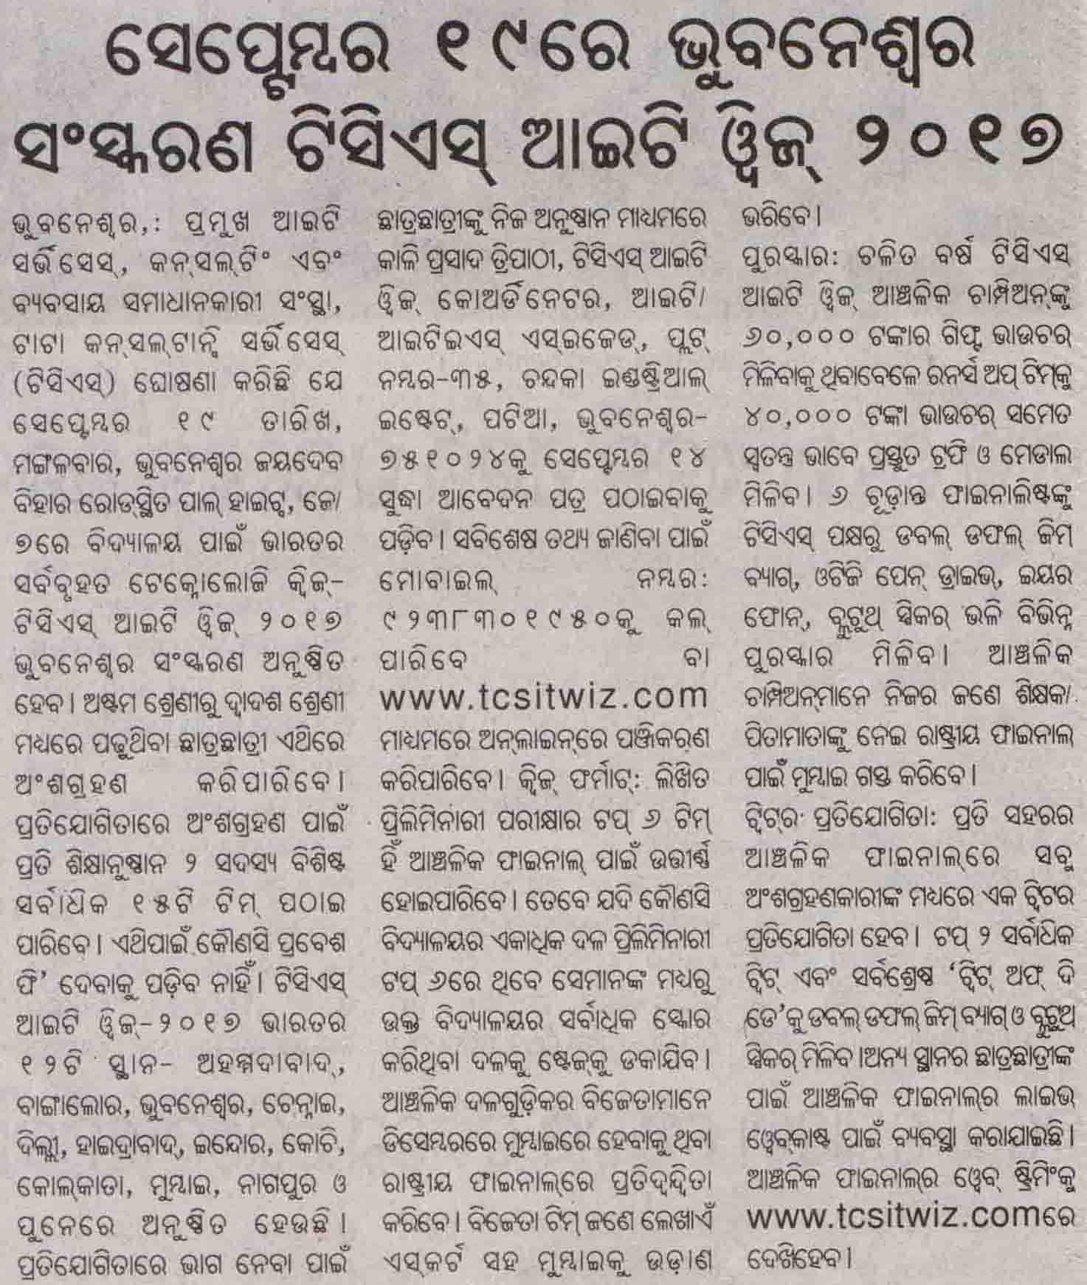

Published Date: | 7 Sept 2017 | Publication: | Sambad
Edition: | Bhubaneshwar | Page No: | 08

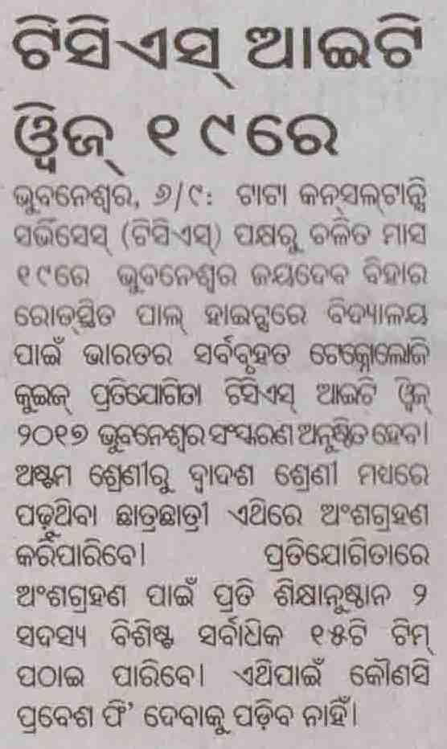

Published Date: | 5 Sept 2017 | Publication: | Kholadwara
Edition: | Bhubaneshwar | Page No: | 07

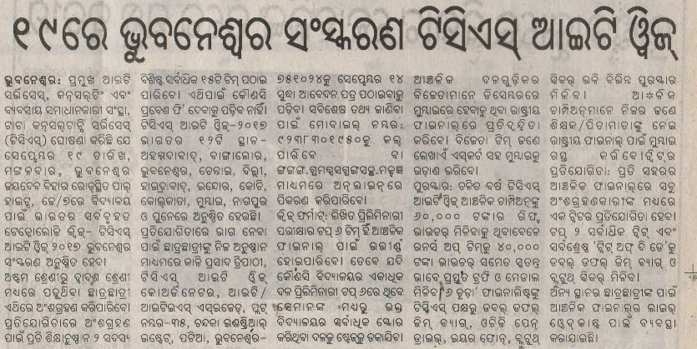

Published Date: | 5 Sept 2017 | Publication: | Paryabekhyak
Edition: | Bhubaneshwar | Page No: | 08

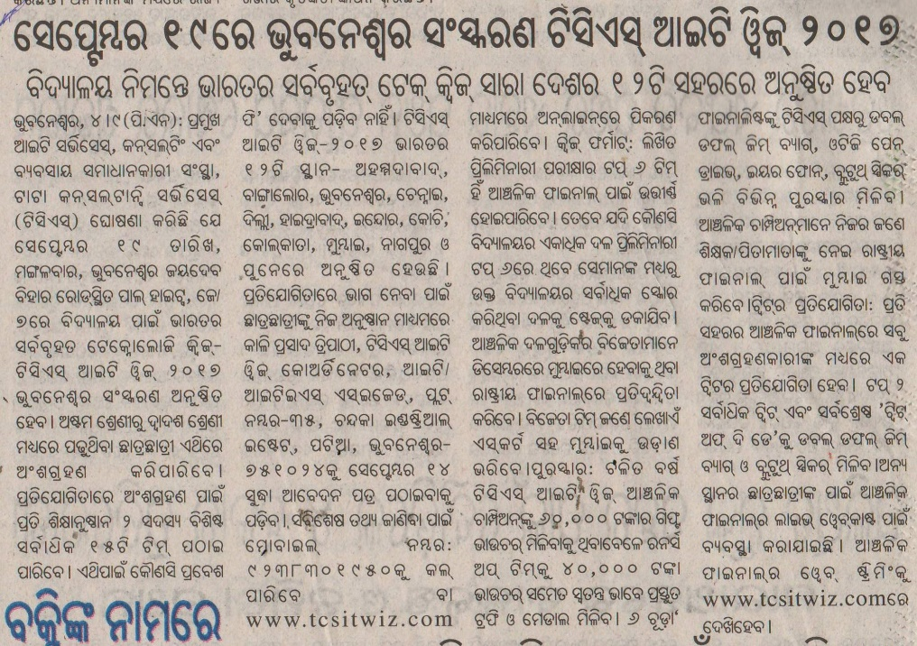

Published Date: | 5 Sept 2017 | Publication: | Darshana
Edition: | Bhubaneshwar | Page No: | 08

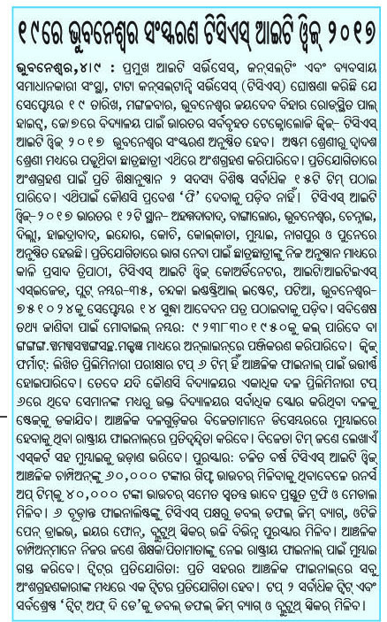

Published Date: | 2 Sept 2017 | Publication: | Sanmarg
Edition: | Bhubaneshwar | Page No: | 04

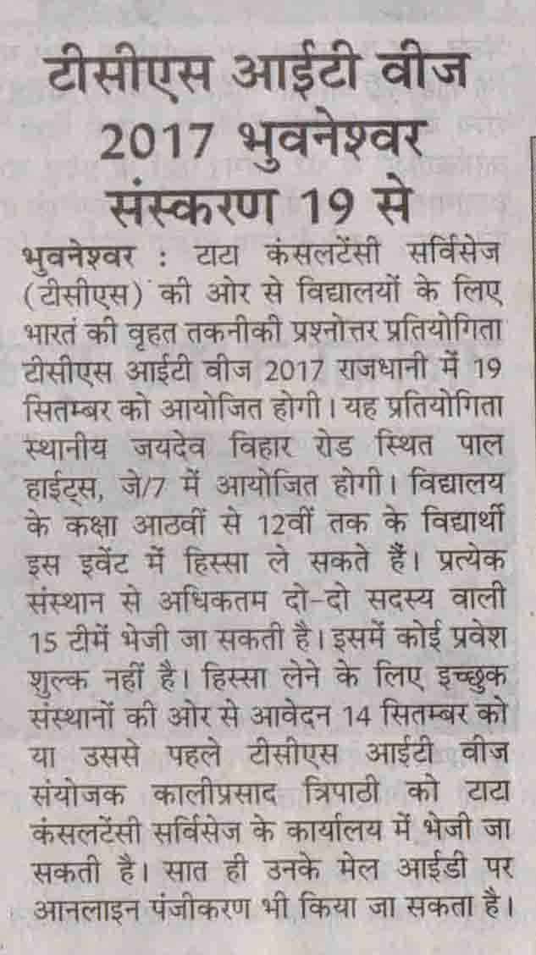

Published Date: | 1 Sept 2017 | Publication: | The Statesman
Edition: | Bhubaneshwar | Page No: | 14

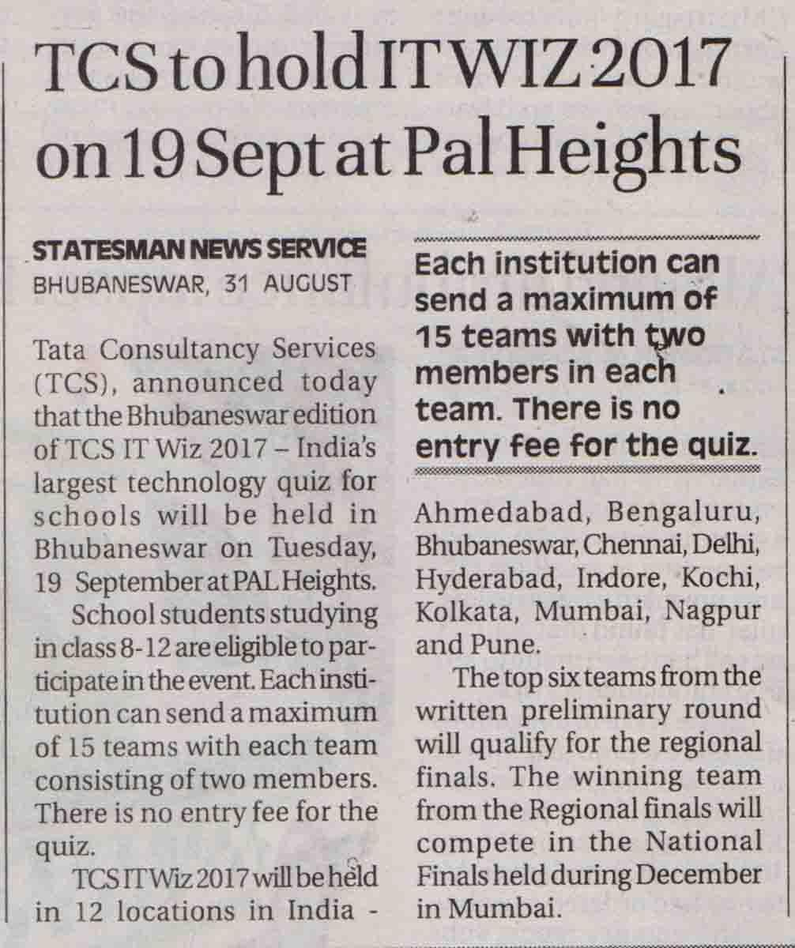

Online

Published Date: | 31 Aug 2017 | Publication: | Orissa Diary
Edition: | Online Web

TCS IT Wiz 2017 Bhubaneswar edition on September 19
http://orissadiary.com/tcs-wiz-2017-bhubaneswar-edition-september-19/

Bhubaneswar: Tata Consultancy Services (TCS), a leading IT services, consulting and business solutions firm, announced today that the Bhubaneswar edition of TCS IT Wiz 2017 – India’s largest technology quiz for schools will be held in Bhubaneswar on Tuesday, September 19, at PAL Heights, J/7, Jaydev Vihar Road, Bhubaneswar.

School students studying in class 8-12 are eligible to participate in the event. Each institution can send a maximum of 15 teams with each team consisting of two member. There is no entry fee.
TCS IT Wiz 2017 will be held in 12 locations in India – Ahmedabad, Bengaluru, Bhubaneswar, Chennai, Delhi, Hyderabad, Indore, Kochi, Kolkata, Mumbai, Nagpur and Pune.
Entries have to be sent through the respective institutions on or before September 14 to Kaliprasad Tripathy, TCS IT Wiz Coordinator, Tata Consultancy Services, IT/ITES SEZ Plot-35, Chandaka Industrial Estate, Patia, Bhubaneswar – 751024, Odisha, India. For further details contact: 09238301950. You can also register online: www.tcsitwiz.com.
Quiz format: The top six teams from the written preliminary round will qualify for the regionals finals. Only the top scoring team from each school will be called on stage in the event of multiple teams from the same school qualify for the final. The winning team from the Regional finals will compete in the National Finals held during December in Mumbai. The winning team along with an escort will be flown to Mumbai.
Prizes: The Regional champion this year will walk away with Rs. 60,000 worth gift voucher while the runners-up will be rewarded Rs. 40,000 voucher along with a specially designed trophy and medals. The 6 finalists will also receive an array of prizes from TCS ranging from Double Duffle Gym bag, OTG pen drive, Earphones, and Bluetooth speakers. The Regional champions along with a teacher/parent will also fly to Mumbai for the National Finals.
Twitter contest: The regional finals in each city will have a Twitter contest for all the participants. The top two highest tweets and the best “tweet of the day” will receive a double duffel gym bag along with a Bluetooth speaker.
To facilitate students of other locations a live webcast of the Regional finals has been organised. The web streaming of the Regional finals can be viewed on: www.tcsitwiz.com.
The Quiz will mainly focus on:
Applications of Information Technology across various industries and sectors including technology environment, the business, people, new trends and legends.
Emerging areas such as cloud computing, AI, biometrics, robotics, world of Internet, unique web sites, IT buzzwords and acronyms.
Areas where IT has made an impact – web, education, entertainment, books, music, movies, banking, advertising, sports, gaming, social media and world of mobiles.
IT Personalities – Global, national and local, brands of IT and communication companies, software products and brands, the history of IT as well as its humorous side of Information Technology.

