Coverage Report
TCS IT Wiz 2017
Bhubaneshwar
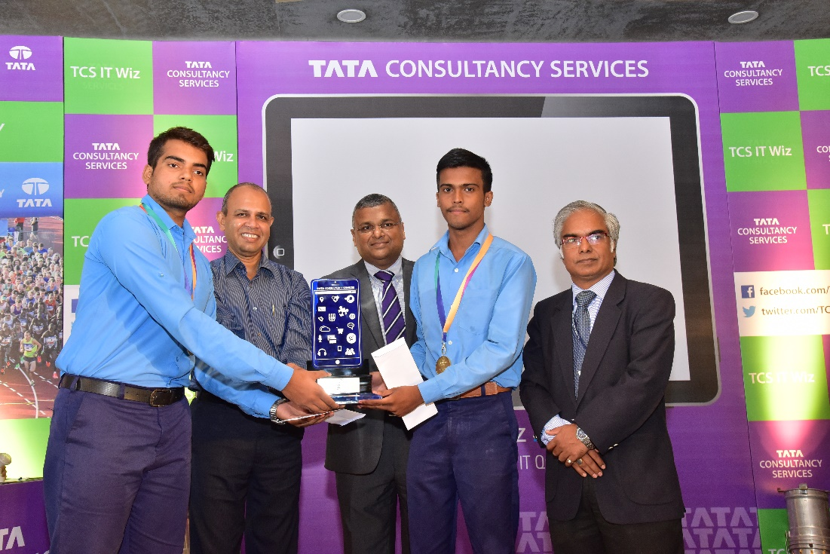
19 September 2017

Article Date | Headline / Summary | Publication | Edition | Page No. | Journalist
Mainlines
21 Sep 2017 | Ravenshaw students emerge champs | The Times of India | Bhubaneshwar | 5 | Bureau
20 Sep 2017 | RAVENSHAW CLINCHES TCS QUIZ | Orissa Post | Bhubaneshwar | 2 | Bureau
20 Sep 2017 | Over 800 State capital students participate in TCS Wiz quiz | The Political and Business Daily | Bhubaneshwar | 2 | Bureau
Regional
21 Sep 2017 | 800 students participated India’s biggest inter-school quiz competition | Darshan (Oriya) | Bhubaneshwar | 8 | Bureau
21 Sep 2017 | Ravenshaw Junior School crowned as winners of TCS IT Wiz Bhubaneswar edition | Hiranchal (Oriya) | Bhubaneshwar | 5 | Bureau
21 Sep 2017 | Ravenshaw Junior School crowned as winners of TCS IT Wiz Bhubaneswar edition | Prameya (Oriya) | Bhubaneshwar | 19 | Bureau
21 Sep 2017 | Ravenshaw Junior School crowned as winners of TCS IT Wiz Bhubaneswar edition | Sanmarg (Hindi) | Bhubaneshwar | 6 | Bureau
20 Sep 2017 | Ravenshaw Junior School crowned as winners of TCS IT Wiz Bhubaneswar edition | Manthan (Oriya) | Bhubaneshwar | 5 | Bureau
20 Sep 2017 | Ravenshaw Junior School crowned as winners of TCS IT Wiz Bhubaneswar edition | Nirbhaya (Oriya) | Bhubaneshwar | 5 | Bureau
20 Sep 2017 | Ravenshaw Junior School crowned as winners of TCS IT Wiz Bhubaneswar edition | Paryabekhyaka (Oriya) | Bhubaneshwar | 8 | Bureau

Mainlines

Published Date: | 21 Sep 2017 | Publication: | The Times of India
Edition: | Bhubaneshwar | Page No: | 5
Circulation: | 63000

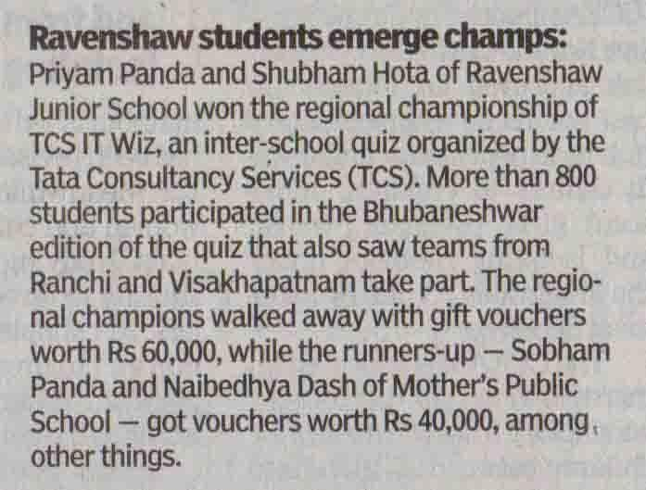
1/1 | Back To Index

Published Date: | 20 Sep 2017 | Publication: | Orissa Post
Edition: | Bhubaneshwar | Page No: | 2
Circulation: | 34251

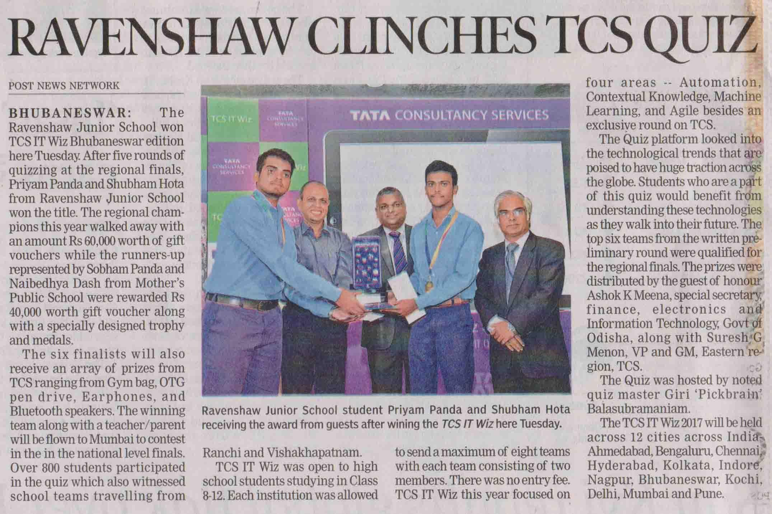
1/1 | Back To Index

Published Date: | 20 Sep 2017 | Publication: | The Political and Business Daily
Edition: | Bhubaneshwar | Page No: | 2
Circulation: | 35000

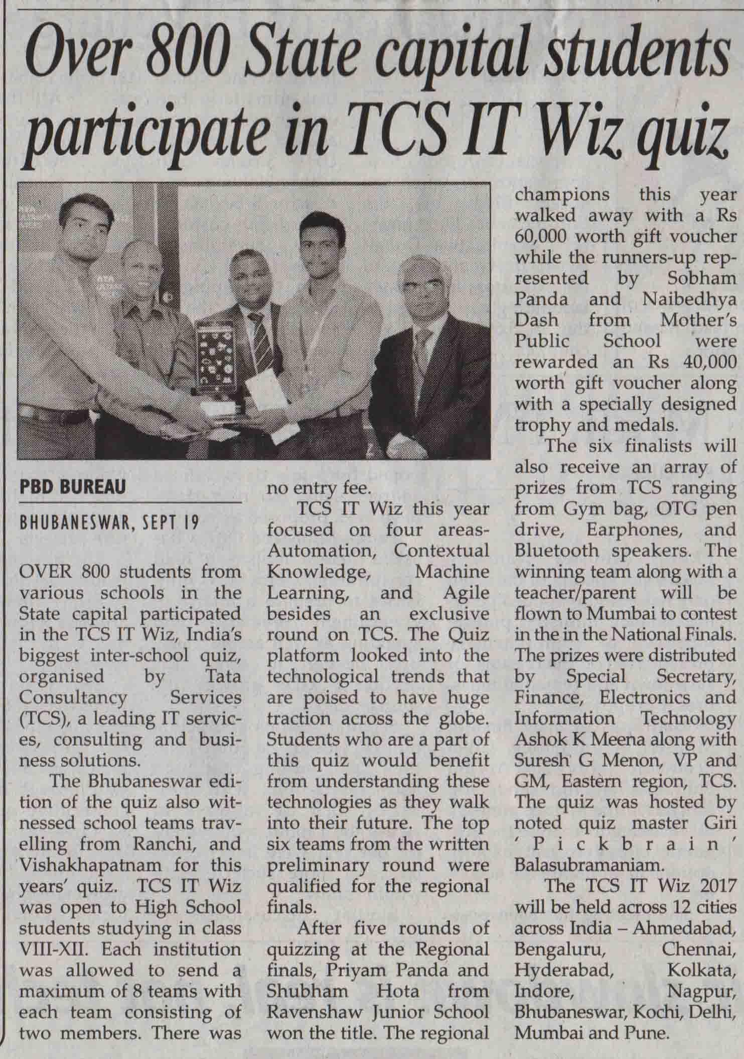
1/1 | Back To Index

Regional

Published Date: | 21 Sep 2017 | Publication: | Darshan (Oriya)
Edition: | Bhubaneshwar | Page No: | 8
Circulation: | 75000

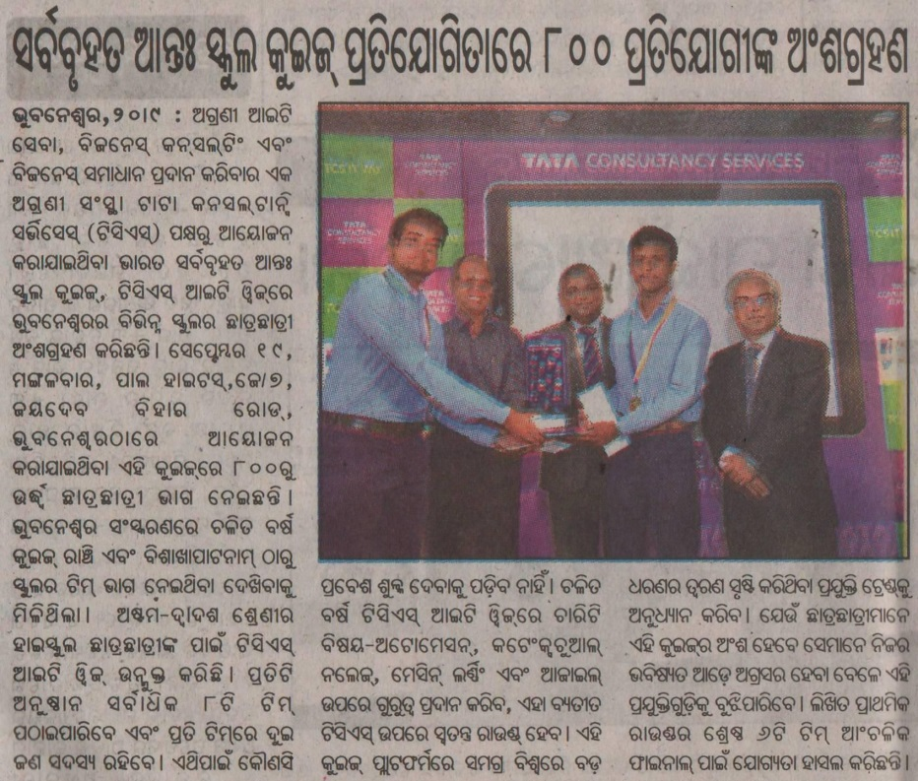
1/1 | Back To Index

Published Date: | 21 Sep 2017 | Publication: | Hiranchal (Oriya)
Edition: | Bhubaneshwar | Page No: | 5
Circulation: | 35000

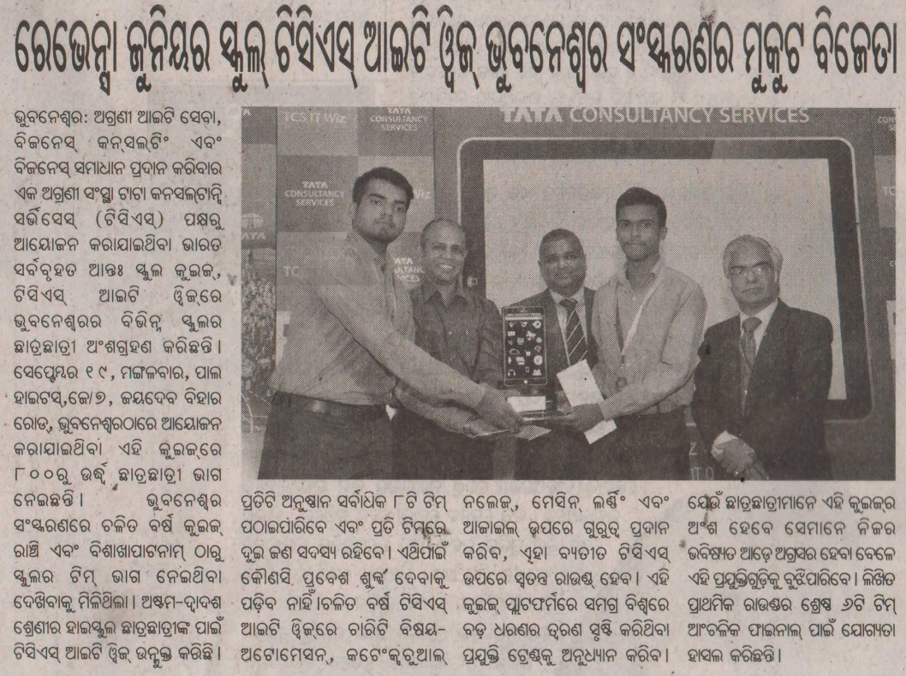
1/1 | Back To Index

Published Date: | 21 Sep 2017 | Publication: | Prameya (Oriya)
Edition: | Bhubaneshwar | Page No: | 19
Circulation: | 133000

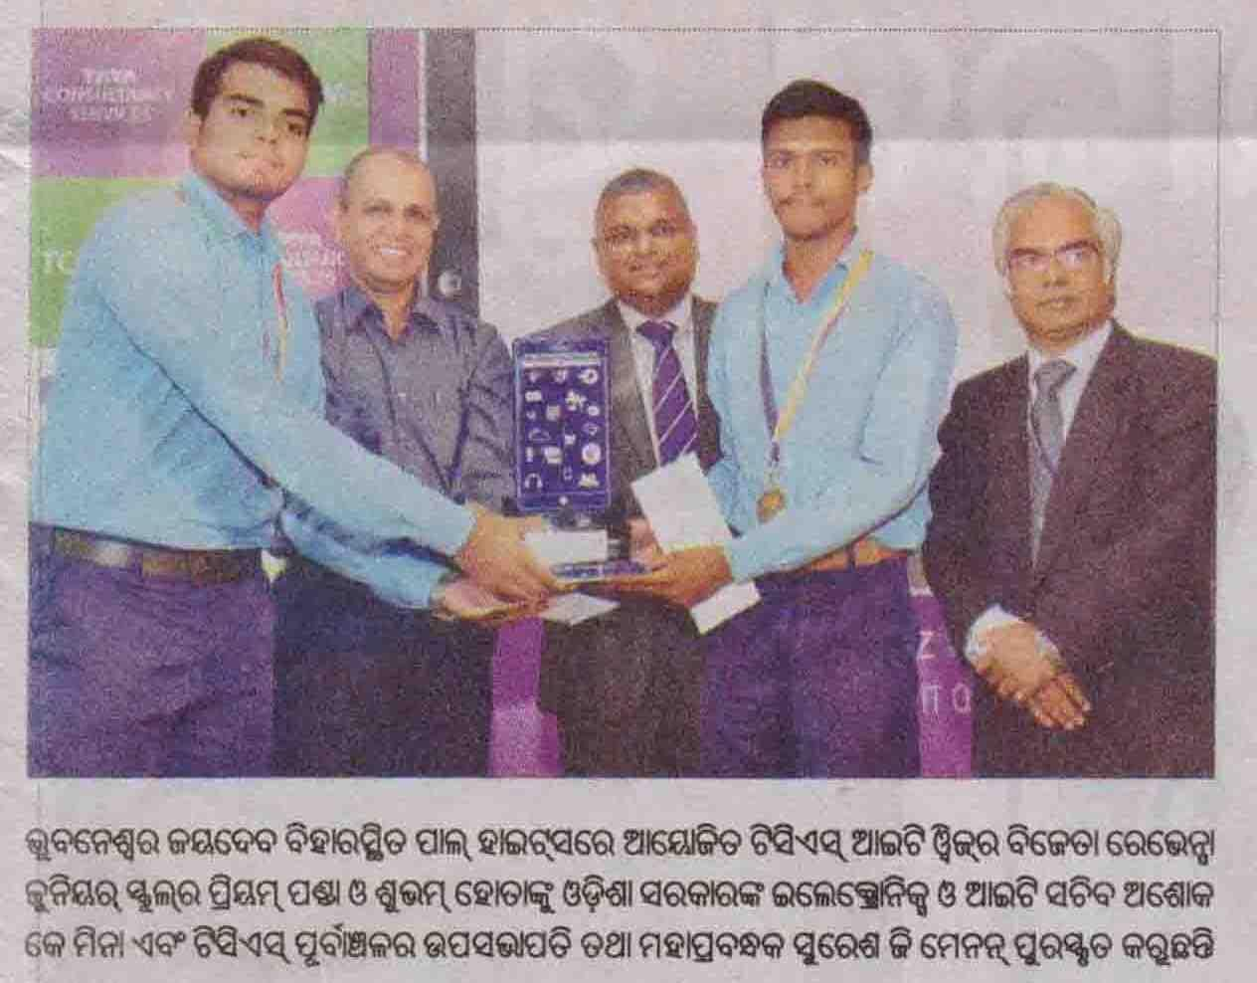
1/1 | Back To Index

Published Date: | 21 Sep 2017 | Publication: | Sanmarg (Hindi)
Edition: | Bhubaneshwar | Page No: | 6
Circulation: | 25000

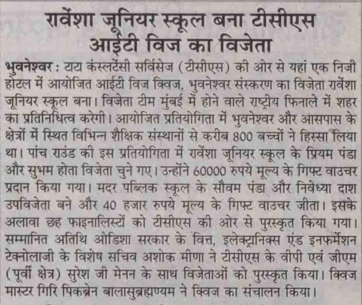
1/1 | Back To Index

Published Date: | 20 Sep 2017 | Publication: | Manthan (Oriya)
Edition: | Bhubaneshwar | Page No: | 5
Circulation: | 12000

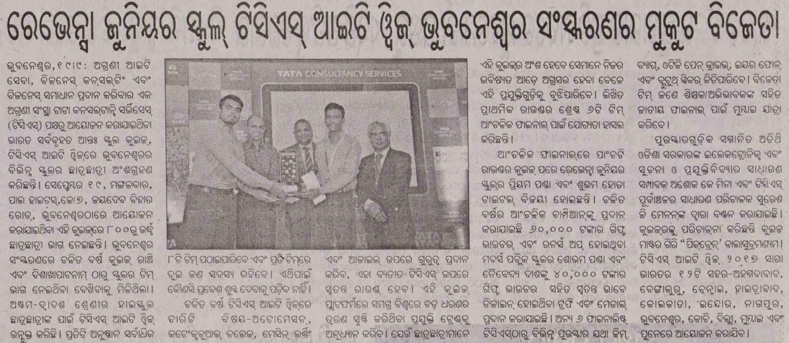
1/1 | Back To Index

Published Date: | 20 Sep 2017 | Publication: | Nirbhaya (Oriya)
Edition: | Bhubaneshwar | Page No: | 5
Circulation: | 12000

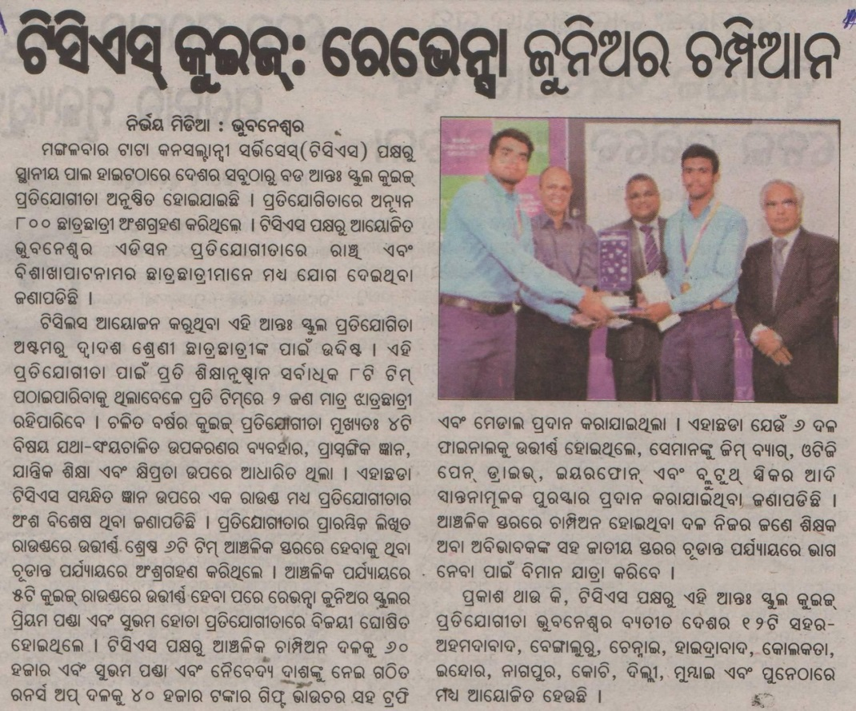
1/1 | Back To Index

Published Date: | 20 Sep 2017 | Publication: | Paryabekhyaka (Oriya)
Edition: | Bhubaneshwar | Page No: | 8
Circulation: | 75000

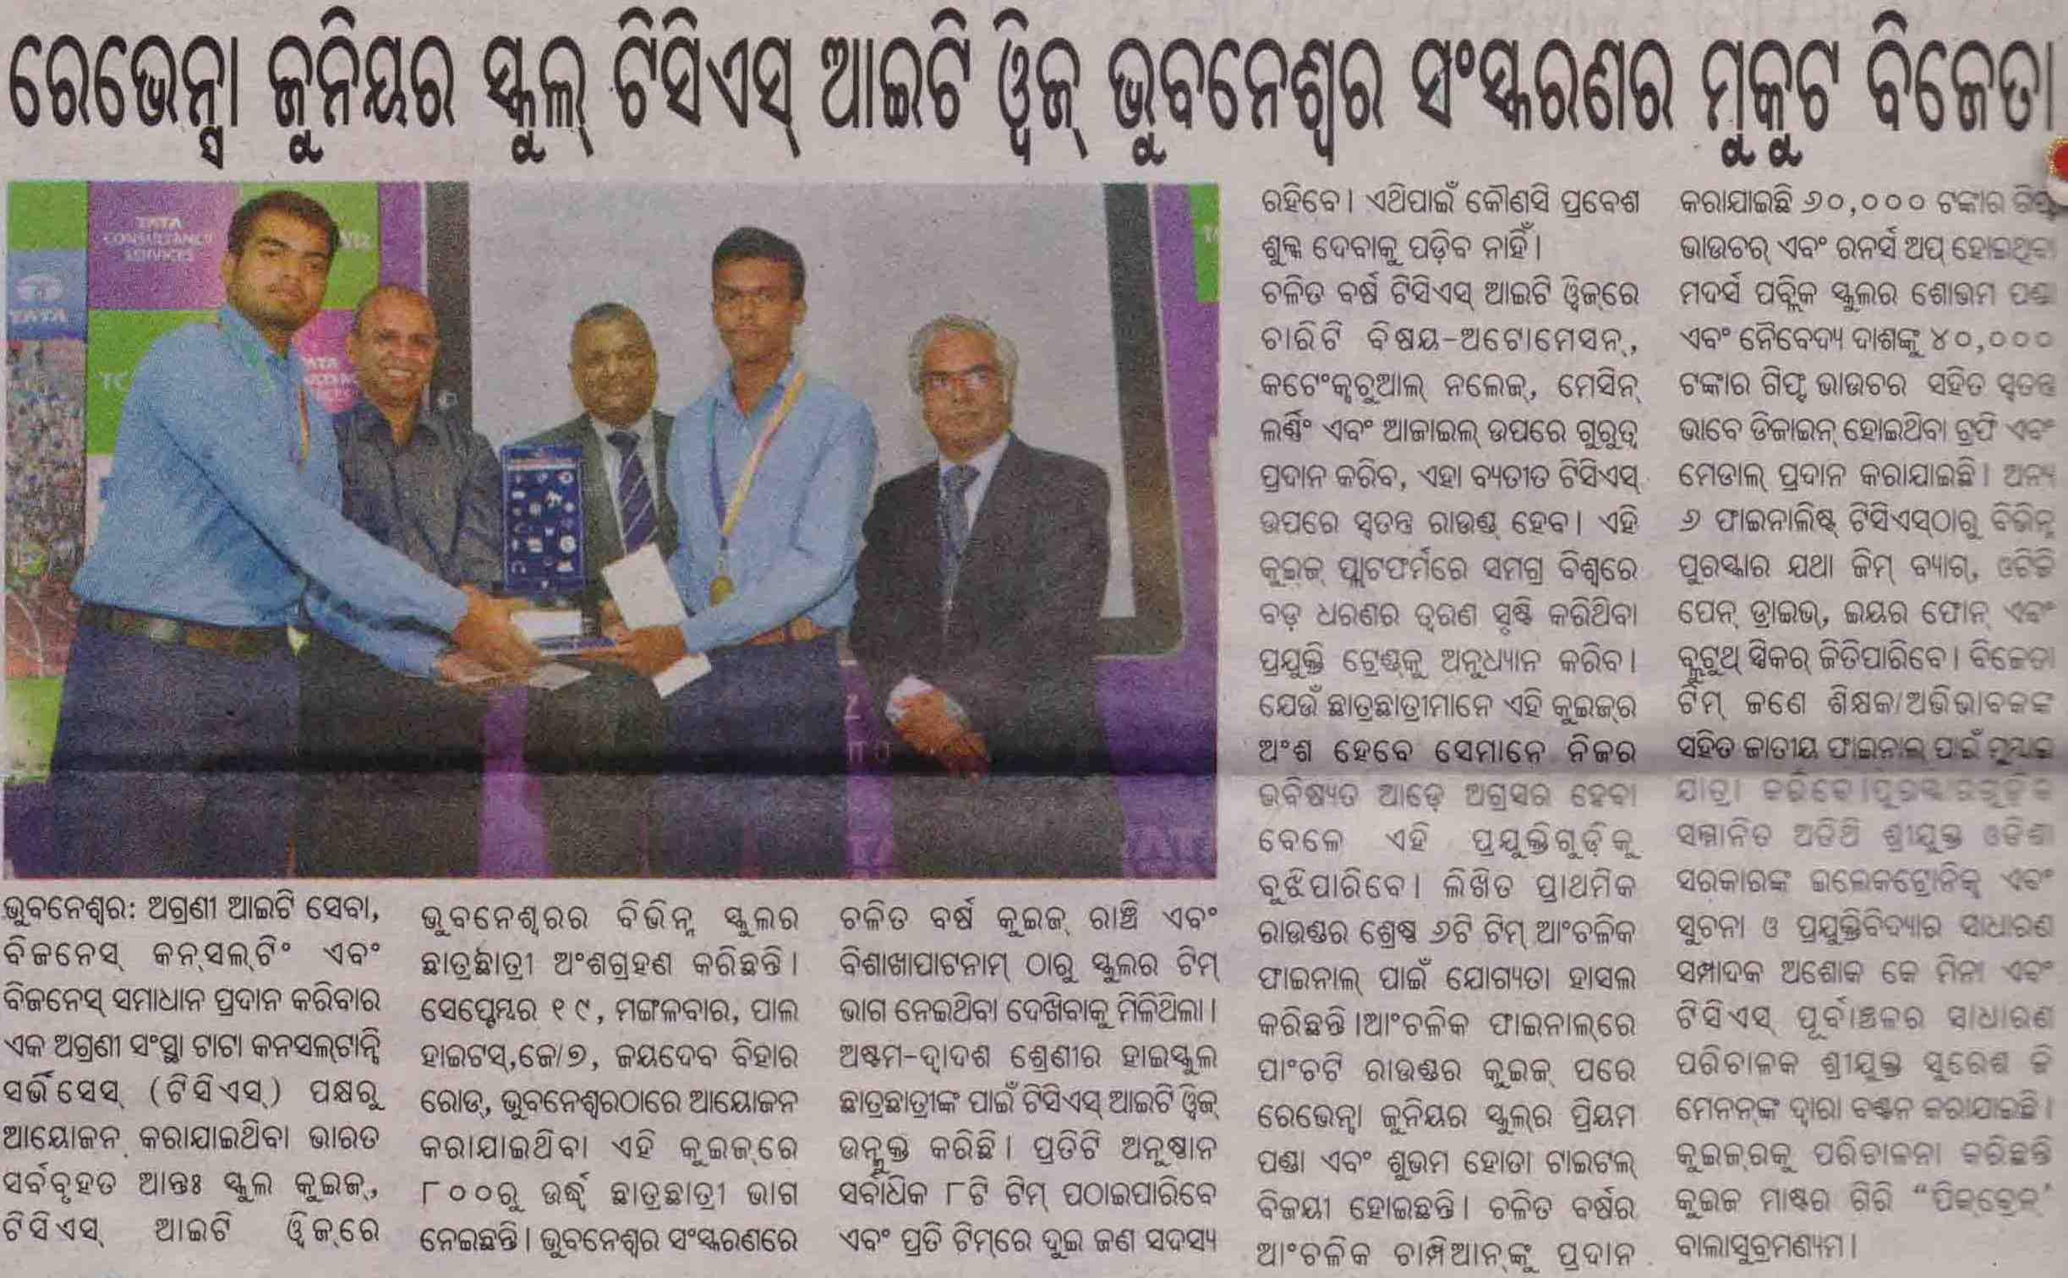
1/1 | Back To Index

